**NEWTON’S SECOND LAW OF MOTION**

**1. A SINGLE OBJECT MOVING ON A HORIZONTAL PLANE WITHOUT FRICTION.**

A 15 kg cement block is pulled across a smooth surface with a force of 100 N, which forms an angle of 14° with the horizontal. Calculate the magnitude of the normal force and the acceleration of the cement block. The effects of friction may be ignored.

**2. A SINGLE OBJECT MOVING ON A HORIZONTAL PLANE WITH FRICTION.**

A 15 kg cement block is pulled across the floor with a force of

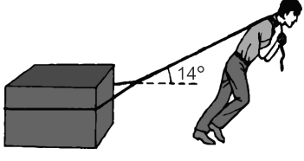

100 N, which forms an angle of 14° with the horizontal. The kinetic friction coefficient between the block and the floor is 0,4.

Calculate the acceleration of the cement block.

**3. A SINGLE OBJECT MOVING ON AN INCLINED PLANE WITHOUT FRICTION.**

An inclined surface is at an angle of 35° to the horizontal. Due to an applied force, F, parallel to the surface, the object of mass 12 kg accelerates at 1,5 m∙s-2. Ignoring all frictional forces, calculate the magnitude and direction of F if the:

3.1 Acceleration is upwards, along the surface

3.2 Acceleration is downward, along the surface

**4. A SINGLE OBJECT MOVING ON AN INCLINED PLANE WITH FRICTION.**

Richard pulls a crate of mass 20 kg with the help of a rope up along an inclined plane as shown. The tension in the rope is 147 N and the coefficient of kinetic friction between the crate and the inclined plane is 0,1 while it moves up the inclined plane. Calculate the acceleration of the block.

147 N

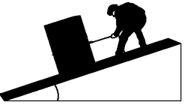

**5. A SINGLE OBJECT MOVING IN THE VERTICAL PLANE.**

A moving company needs to lift a 320 kg piano to the top floor of an apartment building. They set up a rope and pulley system on the balcony of the upper story apartment, and pull

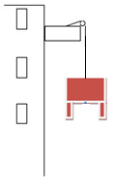

the piano up. If the piano initially has an acceleration of 0,45 m.s-2, what is the

tension in the rope during that period of time?

**SOLUTION**

**Step 1: Draw a free body diagram** T

w

**6. TWO-BODIES JOINED BY A LIGHT INEXTENSIBLE STRING, BOTH ON A FLAT HORIZONTAL PLANE WITHOUT FRICTION.**

Three blocks of masses 1 kg, 2 kg and 3 kg moves on a frictionless horizontal surface under the

influence of a force of 42 N as shown.

Calculate the:

1 kg

2 kg

3 kg

42 N

6.1 Acceleration of the system

6.2 Tension in rope joining the 1 kg and the 3 kg blocks

6.3 Force exerted by the 1 kg block on the 2 kg block

1. **TWO BODIES JOINED BY A LIGHT INEXTENSIBLE STRING, BOTH ON A FLAT HORIZONTAL PLANE WITH FRICTION.**

Two blocks of masses 2 kg and 3 kg, joined by a light inelastic string, move on a rough horizontal

surface under the influence of a force of 42 N as shown. The coefficients of kinetic friction between the surface and the 2 kg and 3 kg blocks are 0,1 and 0,15 respectively.

2 kg 3 kg

Calculate the tension in the rope joining the two blocks.

1. **TWO-BODIES JOINED BY A LIGHT INEXTENSIBLE STRING, ONE ON A HORIZONTAL PLANE WITHOUT FRICTION, AND A SECOND HANGING VERTICALLY FROM A STRING OVER A FRICTIONLESS PULLEY.**

In the diagram below, a 1 kg mass on a smooth horizontal surface is joined to a 2 kg mass by a light, inextensible string running over a frictionless pulley.

1 kg

2 kg

Calculate the tension in the string.

1. **TWO-BODIES JOINED BY A LIGHT INEXTENSIBLE STRING, ONE ON A HORIZONTAL PLANE WITH FRICTION, AND A SECOND HANGING VERTICALLY FROM A STRING OVER A FRICTIONLESS PULLEY.**

In the diagram below, a 1 kg mass on a rough horizontal surface is joined to a 2 kg mass by a light, inextensible string running over a frictionless pulley. The coefficient of kinetic friction between the 1 kg mass and the surface is 0,13.

1 kg

2 kg

Calculate the tension in the string.

1. **TWO-BODIES JOINED BY A LIGHT INEXTENSIBLE STRING, BOTH ON AN INCLINED PLANE WITHOUT FRICTION.**

Two objects of mass 6 kg and 3 kg respectively are connected by a light inelastic string. They are

pulled up a frictionless inclined plane which makes an angle of 30° with the horizontal, with a force of magnitude F. The mass of the string may be ignored.

F

3 kg

6 kg

30°

Calculate the:

10.1 Tension in the string if the system accelerates up the inclined plane at 4 m∙s-2

10.2 Magnitude of F if the system moves up the inclined plane at CONSTANT VELOCITY

1. **TWO-BODIES JOINED BY A LIGHT INEXTENSIBLE STRING, BOTH ON AN INCLINED PLANE WITH FRICTION.**

Two objects of mass 6 kg and 3 kg respectively are connected by a light inelastic string. They are

pulled up an inclined plane which makes an angle of 30° with the horizontal, with a force of magnitude F. The mass of the string may be ignored.

F

3 kg

6 kg

30°

The coefficient of kinetic friction for the 3 kg object and 6 kg object respectively is 0,1 and 0,2.

Calculate the:

11.1 Tension in the string if the system accelerates up the inclined plane at 4 m∙s-2

11.2 Magnitude of F if the system moves up the inclined plane at CONSTANT VELOCITY

1. **TWO-BODIES JOINED BY A LIGHT INEXTENSIBLE STRING, BOTH HANGING VERTICALLY FROM A STRING OVER A FRICTIONLESS PULLEY.**

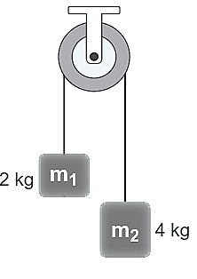

Two blocks, one with a mass of 2 kg and the other with a mass of 4 kg, hang over a frictionless pulley on a thin, light rope.

Calculate the:

12.1 Acceleration of the blocks

12.2 Tension in the rope