GRADE 12 REVISION 2022
MECHANICS: VERTICAL PROJECTILE MOTION

A projectile | An object upon which the only force acting is the force of gravity.

STRUCTURED QUESTIONS

1. A boy stands at the edge of a high cliff. He throws a stone vertically upwards with an initial velocity of 10 m·s⁻¹. The stone strikes the ground at a point below the cliff after 3,5 s. The velocity-time graph below was obtained from measurements made during the motion of the stone.
1
2
3
4
Time(s)
Velocity (m·s⁻¹)
0
5
- 5
10
- 10
- 15
- 20
- 25
Graph of velocity versus time

Use the information on the graph to answer the following questions:

1.1 Calculate the acceleration of the stone between times t = 2 s and t = 3 s. (3)

1.2 At which time(s) is the stone moving at a speed of 5 m·s⁻¹? (2)

1.3 After how many seconds does the stone reach its highest point? (1)

1.4 Determine the height of the cliff from which the stone was thrown. (4)

1.5 Using the top of the cliff as the initial position of the stone, sketch the position-time graph (displacement-time graph) for the motion of the stone from its highest point until it reaches the ground. Only indicate relevant time values on the x-axis. (3)
[13]

2. The roof of a tall building is 25 m above the ground. A rigid ball of mass 0,3 kg falls freely when dropped from the roof. It strikes the concrete floor on the ground with velocity v₁. It bounces to a maximum vertical height of 6 m. The ball was in contact with the floor for 0,9 s. Ignore the effects of friction.
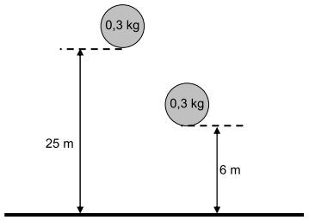

2.1 Calculate the velocity v₁ when the ball first hits the floor. (3)

2.2 Calculate the impulse of the ball as a result of the collision. (7)

2.3 Calculate the magnitude of the net force exerted on the ball. (3)

2.4 Using the ground as zero reference, draw a sketch graph of position (displacement) versus time for the motion of the ball from its original height until it reaches its second maximum height. Indicate the relevant position values on the y-axis. (4)

2.5 The rigid ball is now replaced with a softer ball of the same mass and volume as the rigid ball. It is then dropped from the same height onto the concrete floor. Will the ball reach the SAME, GREATER or LESSER height compared to the previous ball? Use principles of physics to explain your answer. (3)
[20]

3. The following extract comes from an article in a school newspaper.

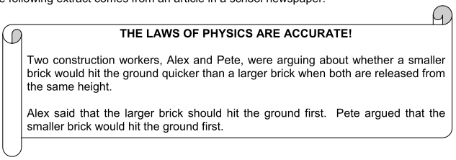

3.1 Are their statements correct? Give a reason for your answer. (3)

3.2 A group of Physical Sciences learners decide to test Alex's and Pete's hypotheses. They drop two bricks, one small and the other much larger, from one of the floors of the school building.
3.2.1 Write down TWO precautions they should take to ensure that the result is reliable. (2)

3.2.2 Give a reason why, despite all the necessary precautions, they might not get the correct result. (1)

3.3 In another experiment, the learners drop a brick A from a height of 8 m. After 0,6 s, they throw a second brick B downwards from the same height. Both bricks, A and B, hit the ground at the same time. Ignore the effects of friction and calculate the speed at which brick B was thrown. (7)
[13]

4. A supervisor, 1,8 m tall, visits a construction site. A brick resting at the edge of a roof 50 m above the ground suddenly falls. At the instant when the brick has fallen 30 m the supervisor sees the brick coming down directly towards him from above. Ignore the effects of friction and take the downwards motion as positive.

4.1 Calculate the speed of the brick after it has fallen 30 m. (3)

4.2 The average reaction time of a human being is 0,4 s. With the aid of a suitable calculation, determine whether the supervisor will be able to avoid being hit by the brick. (6)
[9]

5. A man fires a projectile X vertically upwards at a velocity of 29,4 m·s⁻¹ from the EDGE of a cliff of height 100 m. After some time the projectile lands on the ground below the cliff. The velocity-time graph below (NOT DRAWN TO SCALE) represents the motion of projectile X. (Ignore the effects of friction.)

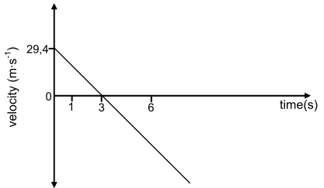

5.1 Use the graph to determine the time that the projectile takes to reach its maximum height. (A calculation is not required.) (1)

5.2 Calculate the maximum height that projectile X reaches above the ground. (4)

5.3 Sketch the position-time graph for projectile X for the period t = 0 s to t = 6 s. USE THE EDGE OF THE CLIFF AS ZERO OF POSITION.

Indicate the following on the graph:
• The time when projectile X reaches its maximum height
• The time when projectile X reaches the edge of the cliff (4)
5.4 One second (1 s) after projectile X is fired, the man's friend fires a second projectile Y upwards at a velocity of 49 m·s⁻¹ FROM THE GROUND BELOW THE CLIFF. The first projectile, X, passes projectile Y 5,23 s after projectile X is fired. (Ignore the effects of friction.)

Calculate the following:

5.4.1 The velocity of projectile X at the instant it passes projectile Y (5)

5.4.2 The velocity of projectile X RELATIVE to projectile Y at the instant it passes projectile Y (5)
[19]

6. The velocity-time graph shown below represents the motion of two objects, A and B, released from the same height. Object A is released from REST and at the same instant object B is PROJECTED vertically upwards. (Ignore the effects of friction.)
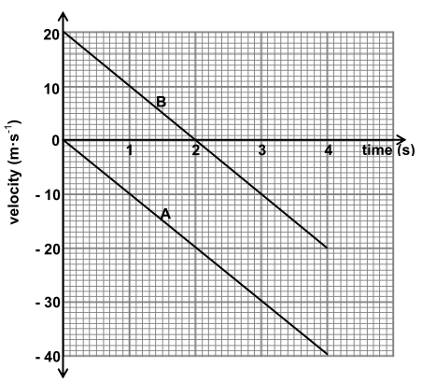

6.1 Object A undergoes a constant acceleration. Give a reason for this statement by referring to the graph. (No calculations are required.) (2)

6.2 At what time/times is the SPEED of object B equal to 10 m∙s⁻¹? (2)

6.3 What is the velocity of object A relative to object B at t = 1 s? (3)

6.4 Object A strikes the ground after 4 s. USE EQUATIONS OF MOTION to calculate the height from which the objects were released. (3)

6.5 What physical quantity is represented by the area between the graph and the time axis for each of the graphs A and B? (2)

6.6 Calculate, WITHOUT USING EQUATIONS OF MOTION, the distance between objects A and B at t = 1 s. (5)
[17]

