**MONYETLA PROJECT – LIFE SCIENCES – 6 APRIL 2024**

**DIFFERENT FORMS OF DOMINANCE**

**Tip:** When you deal with genetic problems in the exams, be quick to **identify the** **type of dominance** in the particular question. Implement the appropriate method for each type of dominance.

1. **Complete Dominance**: Look out for words such as *dominant allele* and *recessive allele*. Capital letters are used to indicate the dominant feature, while lower case of the same letter is used for the recessive allele. Eg in pea plants tall (T) is dominant over short (t). The heterozygous genotype is therefore indicated as Tt.
2. **Incomplete Dominance**: Look out for an intermediate phenotype **(blend)** in the offspring (F1) Eg Red roses x White roses give **Pink** in the offspring. Use CAPITAL LETTERS ONLY. There is no dominance in cases of incomplete dominance, hence no recessive alleles to indicate with lower case. The genotype for the example above may be indicated as follows: RR x WW gives RW (all F1 offspring)
3. **Codominance**: Look out for **both** of the parents phenotypes expressed in the F1-generation. In cases of codominance alleles are **equally dominant** and both show in the offspring. Eg Brown horse x white horse gives a foal with brown and white patches. Use CAPITAL LETTERS ONLY. The example above may be indicated as follows: BB x WW gives BW (all F1 offspring)

We are sure you can do the following examples from past question papers. Do the questions and then look at the answers. Don’t look at the answers without trying first, that is how we learn!

**DBE 2021 – P2**

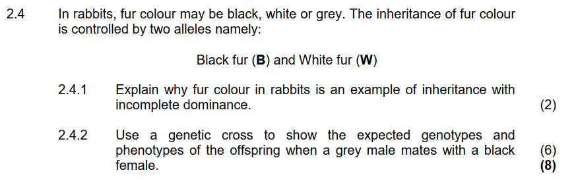

**ANSWER**

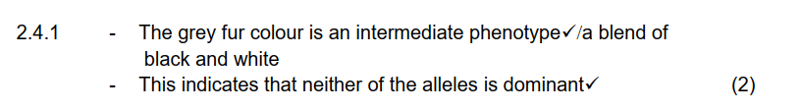

2.4.2

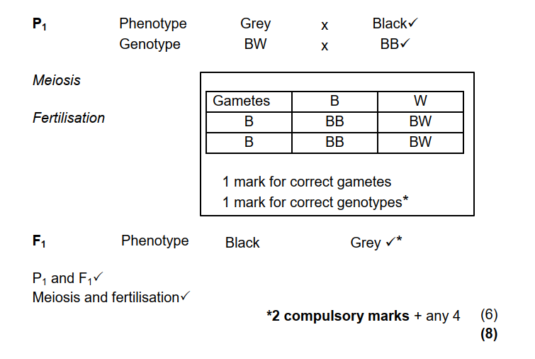

**Nov 2016 - P2**

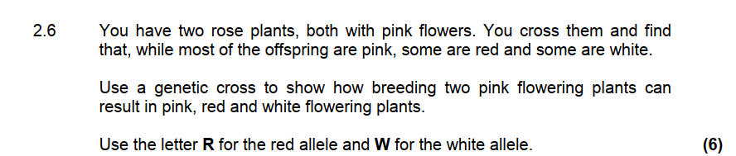

**ANSWER**

2.6 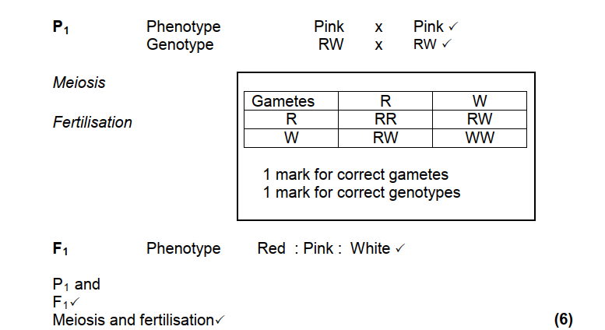

**Nov 2016 – P2**

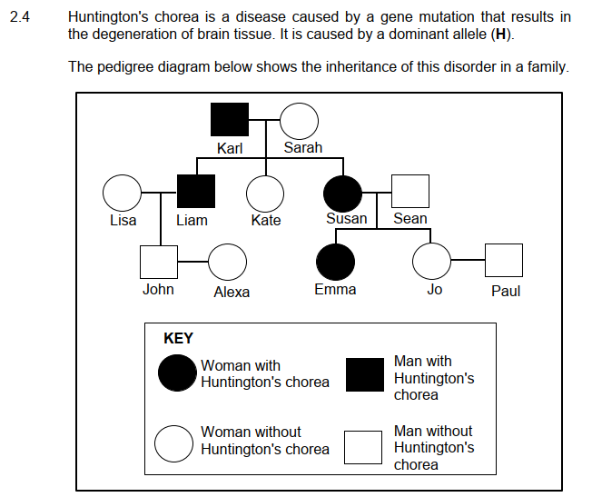

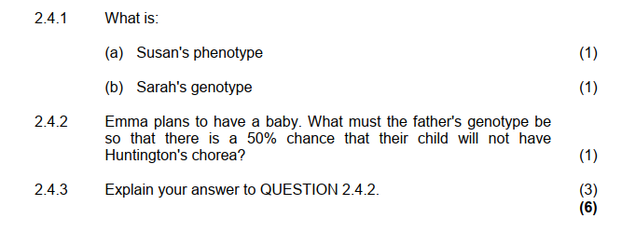

**ANSWER** 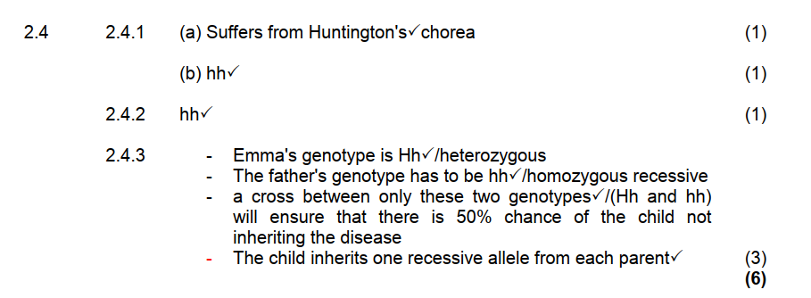

**Question 4**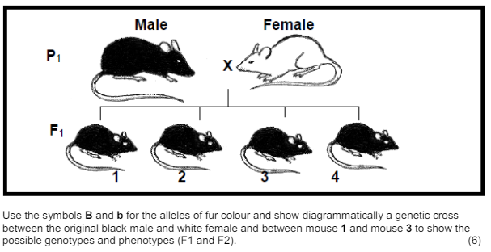

**Question 5**

Red Petunias were crossed with white petunias. All the flowers of this genetic cross were red with white stripes.

5.1 Explain why this is an example of co-dominance. (2)

5.2 Calculate the % Red offspring if 2 Red/White-striped flowers were crossed. (3)