**ECONOMIC CIRCULAR FLOW**

**Description**

* The circular-flow model of the economy is a simplification showing how the economy works and the relationship between income, production and spending in the economy as a whole.
* The circular-flow model of an open economy shows the workings of an economy that is open to foreign trade.
* It is different to a closed economy because it includes the foreign sector.

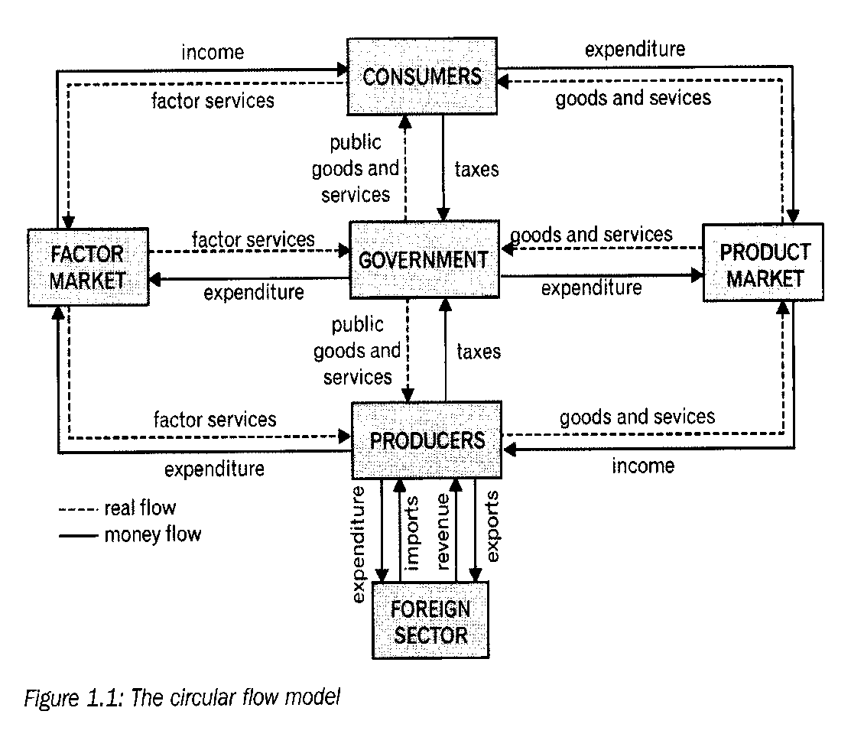

**(Enjoy Economics)**

**Households**

* There is a flow of money and goods and services between the household sector and business sector
* Households are the owners of the services of factors of production and they place their factors of production on the market so that it can be bought.
* Households earn income in the form of wages by selling their factors of production to business.

**Business Sector**

* Business uses factors of production to produce goods and services on which the household sector spends their income
* Businesses place goods and services on the product market which is bought by households to satisfy their needs
* Business receives an income.

**State/Government**

* There is a flow of money and goods and services between the household sector and State.
* Household sector provides the state with labour and receive income.
* The state provides the household with public goods and services
* (e.g.) parks, hospitals
* Households pay taxes to the state.
* This is income for the state.
* There is a flow of money and goods and services between the business sector and State.
* The business sector provides the state with goods and services for which the state pays.
* The state provides the business sector with public goods and services
* E.g. Roads, Electricity, harbours, etc.
* Business pay taxes to the state.

**Foreign Sector**

* There is a flow of goods (imports) to the business from the foreign sector
* Businesses that import these goods, pays for it.
* This will be regarded as expenditure for the business
* There is also a flow of goods (exports) from the business in the country to the foreign sector.
* Businesses export their goods and services to other countries and earn money for it.
* This will be income for the business.

**Financial Sector**

* The financial sector consists of banks, insurance companies and pension funds.
* They act as a link between households and firms who have surplus money and others in the economy who require funds.
* The money which households and firms provide to the financial sector is known as savings.
* Businesses can Borrow money from the financial institutions and use it to purchase capital goods.
* This spending on capital equipment by firms is regarded as investment.

**Real Flow and Money flow**

* Transactions takes place on markets.
* The exchange process has two components, namely

1 **Real flow**: Goods and services and Factors of production.

2 **Money flow**: The earning of money (income) and payments that is made.

**Real flow (8 marks)**

* Consumers render production factors to producers and government via the factor market.
* Goods and services are supplied by producers via the product market to government and consumers.
* Government provides public goods and services to consumers and producers.
* Producers receive goods and services (imports) form and deliver goods and services (exports) to the foreign sector.

**Money Flow**

* Consumers earn an income for their production factors via factors market from businesses.
* Business sector earn an income for goods and services via the product market from consumers and government.
* Government earn an income consumers and businesses
* Businesses earn an income for exports from the foreign sector and make payments to the foreign sector for imports.

**LEAKAGES (L)**

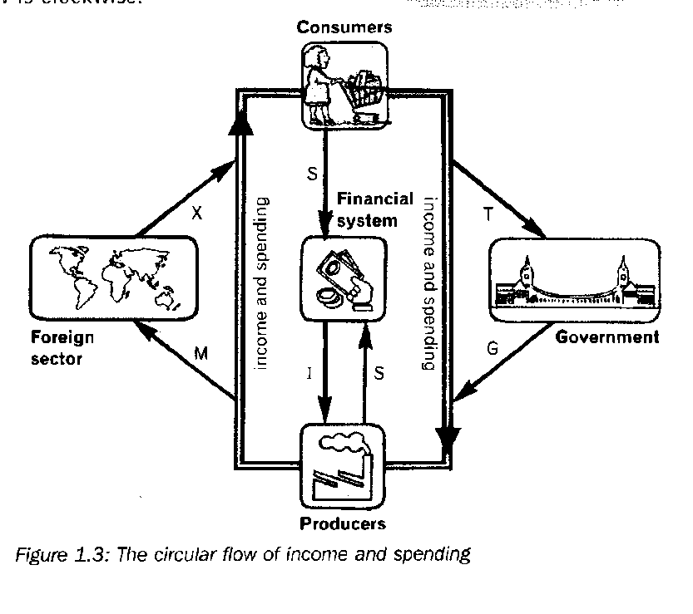

**(Enjoy Economics)**

**8 marks**

**Leakages**

* A leakage represent the withdrawal of money from the economic cycle (local economy)
* It does not give rise to a further round of income.
* Domestic purchases on goods and services decrease.
* In an open economy, the leakages are taxes (T), the expenditure on imports (Z) and savings (S).

|  |
| --- |
| **In other words:**  **L = S T + M**  Leakages = Savings + Taxes + Import expenditure |

**Injections**

* Injections represents the injection of money into the economic cycle (local economy)
* It refers to the flow of any spending which is not derived from income (Y)
* Additional money enters the economy and it increases income
* Domestic purchases on goods and services increase
* In an open economy, injections are government spending (G), the revenue earned from exports (X) and investment spending (I).

|  |
| --- |
| **In other words:**  **J = I + G + X**  Injections = Investments + Government expenditure + Export Income |

**Equilibrium**

* The economy is in equilibrium when leakages are equal to Injections.
* In other words

L = J

S + T + M = G + I + X

**Disequilibrium**

* The economy is in disequilibrium when:

1. Leakages are more than Injections.
2. Injections are more than leakages.

**Restoring the equilibrium causes changes to national income.**

1. **National Income increase when Injections are more than Leakages.**

J > L

G + I + X > S + T + M

* The amounts of injections which exceed leakages contribute to additional demand.
* This additional demand must be satisfied.
* This causes in increase in the production of goods and services.

E.g.

J > L

1. **National Income decrease when Injections are less than Leakages.**

J < L

I + G + X < S + T + M

* The amount with which leakages exceeds the injections contribute to a decreased demand.

J < L

* Demand for goods and services drop..
* Less goods and services are produced.
* Less income

**Mathematical and Graph Presentation**

* **Income (Y) is equal to Expenditure (E)**

|  |
| --- |
| **In other words**:   * Y = E   **Y = C + G + I + (X-M) = E = C + G + I + (X-M)** |

**Mathematical Calculation**

|  |  |
| --- | --- |
| Imports | R40 million |
| Investment Spending | R180 million |
| Consumption Spending | R 110 million |
| Exports | R 25 million |
| Government Spending | R110 million |

The Formula to calculate the Aggregate Income in the economy:

Y = C + I + G + (X-M)

Calculation of the aggregate Income in the economy.

Y = C + I + G + (X-M)

Y = R110 million + R180 million + R110 million + (R25 million – R40 million)

Y = R385 million

**Graphical Presentation**

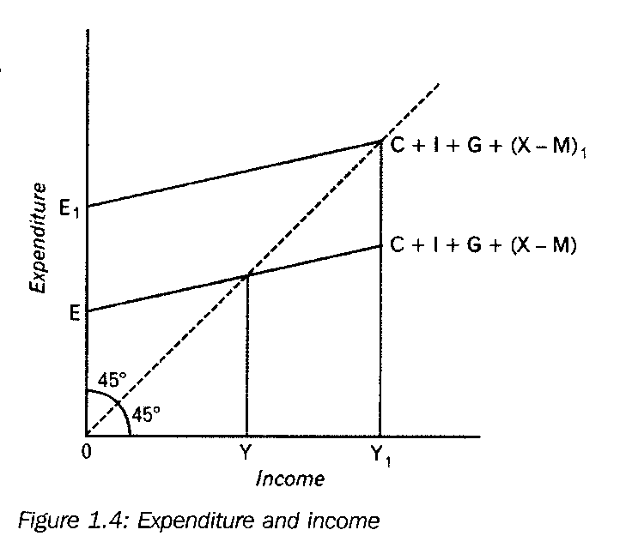

**(Enjoy Economics)**

* Expenditure is (E) and it is shown on the Vertical axis.
* Income is (Y) and it is shown on the Horizontal axis.
* E = Y and it is separated by Scale line.
* It halves the 900 angle into two equal portions of 450
* Aggregate Expenditure (AE) = C + I + G + (X-M)
* This curve shows the amount which consumers, producers, government and foreign sector plans to spend at every level of income.
* It also equals aggregate demand.
* The curve slope upwards and to the right.
* At an income of Y the AE intersects the vertical axis at E.
* If planned AE increase to E1
* This means more money is injected into the economy than what are leak out.
* This cause an increase of Y to Y1.

**MARKETS**

**STUDY AS AN ESSAY**

**Product market**

* These are markets for consumer goods.
* Buying and selling of goods that are produced in markets.
* E.g.
* Durable consumer goods**.**
* Semi durable consumer goods.
* Non-Durable consumer goods
* Services

**Foreign Exchange market**

* E.g.
* It is when a person buys travelers cheques to travel abroad.
* Businesses buy foreign currency to pay for imported goods and services.
* In S.A these transaction occur in banks.
* The most important foreign exchange markets are in London, New York and Tokyo.
* The S.A Rand are traded freely on these markets and the SARB has no control over it.

**Capital markets**

* Here long term funds are borrowed and saved by consumers and business enterprises.
* E.g. Mortgage bond.
* The Johannesburg Stock exchange is a key institution in the capital market.
* Shares are traded here.

**Money market**

* Here short term loans and very short term funds are saved and borrowed by the consumers and business enterprises.
* Banks, Insurance companies are examples.
* Bank debentures, treasury bills, government bonds are trade here.

**Factor market**

* On this market the services for factors of production are traded.
* Natural resources, Labour, Capital, and Entrepreneurship are trade on this market.

**National Accounts**

**The aim of National accounts**

* It is to provide a systematic and comprehensive record of national economic activities.
* National income figures are NOT 100% accurate.
* There are many shortcomings or problems when we calculate or determine national income figures.
* Irrespective of all these problems and shortcomings, it still remains important economic statistics.
* South Africa uses the System of National accounts (SNA) - as suggested by the United Nations (UN)

**COMPOSITION OF NATIONAL ACCOUNT**

* GDP is total value of final goods and services, produced within the boundaries/borders of a country for a specified period.
* GNP is total value of final goods and services produced by the permanent residents of a country for a specific period.
* Another name for GDP is : Gross Value Added

**THREE METHODS THAT IS USED TO CALCULATE GDP**

* Production method
* Expenditure method
* Income method

**When the GDP is calculated and the:**

|  |  |
| --- | --- |
| Method | Answer is known as |
| Expenditure method | GDP (E) |
| Production method | GDP (P) |
| Income method | GDP (I) |

**1. THE PRODUCTION METHOD (VALUE ADDED APPROACH / METHOD)**

* When using this method, the GDP is determined by calculating the sum of the value added at each stage of the production process.
* This method yields GDP at basic prices.
* It is the quantity multiplied with the market or production price.
* To avoid double counting, only added values are taken.
* The value of intermediate goods and services are not included in the calculation.

|  |  |
| --- | --- |
| **Value Added** | **R Billions** |
| Primary Sector | 129 |
| Secondary Sector | 316 |
| Tertiary sector | 908 |
| **Gross value added at basic prices** | **1353** |
| **Plus**: Taxes on production | 174 |
| **Less**: Subsidies on products | 4 |
| **Gross domestic product at market prices** | **1523** |

**2. EXPENDITURE APPRAOCH (METHOD)**

* When using this method, the GDP measure the total value of expenditure (spending) on final goods and services, at market prices, within the geographical borders of the country in a specific period of time.
* The spending of the four spenders in the economy is added together.
* That is spending by households, business enterprises and state, on consumer goods, services and capital goods.

|  |  |
| --- | --- |
| **Expenditure method** | **R Billions** |
| Final consumer spending on goods and services | 968 |
| Final consumer spending by the general government | 307 |
| Gross capital formation | 278 |
| **Residual items** | **8** |
| Gross domestic expenditure | 1545 |
| Exports of goods and services | 413 |
| **Less: Imports of goods and services** | **435** |
| **Expenditure on GDP at market prices** | **1523** |

1. **INCOME APPROACH (METHOD)**

* When using this method, GDP measure the total remuneration earned by the owners of factors of production within the geographical borders of a the country for their services of their factors in the production process over a period of time (year).
* It is based on factor cost.

|  |  |
| --- | --- |
| **Income method** | **R Billions** |
| Compensation of employees | 680 |
| Net operating surplus | 454 |
| Consumption of fixed capital | 190 |
| **Gross value added at factor cost** | **1324** |
| Other taxes on production | 34 |
| Less other subsidies production | 5 |
| **Gross value added at basic prices** | **1353** |
| Taxes on products | 174 |
| Less subsidies on products | 4 |
| **Gross domestic product at market prices** | **1523** |

* Net operating surplus include the total value of goods and services less the costs.

**Costs consist of:**

1. Intermediate goods and services
2. The cost of compensation of workers
3. The cost of capital consumption.

**NATIONAL ACCOUNT CONVERTIONS**

* All countries use national account figures
* **South Africa uses the SYSTEM OF NATIONAL ACCOUNTS (SNA) prescribed by the United Nations.**
* GDP, GDE, and GDI has a great deal to do with the prices we use such as nominal and real prices, prices before or after taxes.
* Indirect taxes and subsidies are the most important determinants of the end values of the circular flow aggregates.

**Basic Prices**

* Indirect prices and subsidies are related to production process and not individual products.
* With the production method, taxes on production is subtracted as a cost and subsidies on production are added as a income.
* Taxes on production are payroll taxes (SITE and PAYE), recurring taxes on land & buildings, Business licenses.
* Subsidies on production include employment subsidies and subsidies paid to prevent pollution.

**Factor Cost**

* GDP at basic prices – other taxes on production + other subsidies on production = GDP at factor cost (factor income).

**Market prices**

* Conversion of values form:
* **Basic prices to market prices:**

GDP ate basic prices + Taxes on products – subsidies on products = GDP at market prices.

* **Factor cost to market prices:**

GDP at factor cost + other taxes on production – subsidies on production = GDP at basic prices + taxes on products – subsidies on products = GDP at market prices.

**Net figures**

Net operating surplus = surplus after taxes

Net income = income after taxes

Net fixed capital formation = After consumption of fixed capital ( depreciation)

Net exports = exports – imports

**Conversion of Domestic to National figures**

Domestic figures relate to the income and production happening within the boarders of the country.

National figures relate to the income or production by the citizens of the country.

E.g.

|  |  |
| --- | --- |
|  | **R Billions** |
| **GDP at market prices** | **1523** |
| Plus: Factor income earned abroad by South Africans | 29 |
| Less: Factor income earned in South Africa by foreigners | 60 |
| **GNI at market prices** | **1492** |

**Nominal figures VS Real figure**

**Nominal figures**

* It is also known as nominal or money value.
* It is also known as national product at current price.
* Production is calculated by multiplying the volume of the final goods and services by their prices.
* Inflation has not yet been taken into consideration.

**Real figures**

* It is also known as national product at constant prices.
* The rate of inflation as expressed by the consumer price index (CPI) has been taken into account.
* Real values of production are the nominal values of national product adjusted for price increase.
* Real national product is the national product express in prices which applied in a certain base year.

**The Multiplier**

**Defn:**

The multiplier shows how an increase in spending (injection) produces a more than proportional increase in national income

* **The multiplier must always be more than 1.**
* The multiplier works in opposite directions.

**THE MULTIPLIER IN A TWO SECTOR MODEL.**

1. **The multiplier derived from the marginal propensity to consume (mpc)**

* The size of the multiplier depends on the proportion of any increase in income that is spent.
* The larger the MPC the bigger the multiplier and the smaller the MPC the smaller the multiplier.
* It is the money that stays in the economy.

E.g.

Y = R100 000

S = R 40 000 = 40% 0,4

E = R 60 000 = 60% 0,6

* **Marginal Propensity to consume = 0,6 (mpc)**
* **Marginal propensity to save = 0,4 (mps)**

**The total of the MPC + MPS is always = 1 (one)**

**FORMULE to calculate the Multiplier:**

__1 __

α = 1 – mpc

__1__ = 1 = 1

α = 1 – mpc 1 – 0,6 0,4

= **2½/ (Multiplier)**

**THE MULTIPLIER IN A FOUR SECTOR CIRCULAR FLOW MODEL**

* The following leakages are found

1. mps = marginal propensity to save
2. mrt = marginal rate of taxation
3. mpm = marginal propensity to import

The formula in a four sector model is as follows:

**1 = 1_______**

**α = 1 – mpc mps + mrt + mpm**

* Changes in I, G, X will have a change in income.

**THE MULTIPLIER IN A GRAPH**

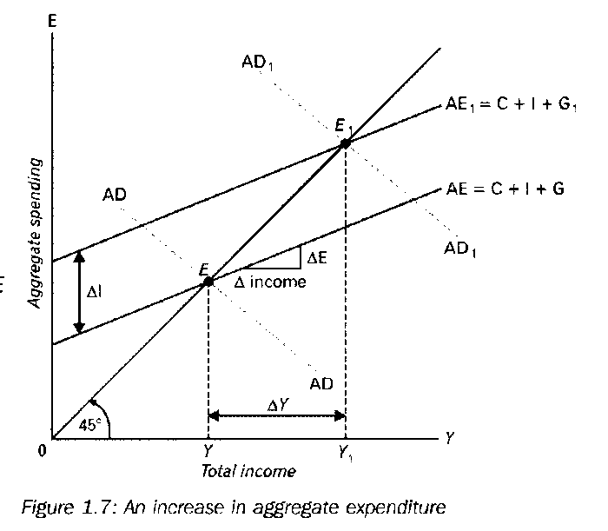

**Use thefollowing formula to calculate the Multiplier**

∆Y

K = ∆ I

* I = R40 000 m and it increase to R50 000 m
* ∆ I = R10 000 m : in other word investment in infrastructure and development and building of houses
* Y = R100 000 m vermeerder na R125 000 m
* ∆Y = R25 000 m

∆Y

K = ∆ I

R25 000

R10 000 = 2.5 = 2½

* **In the above sketch:**
* E = Original equilibrium.
* Y = Original income.
* Investment spending is added.
* Total spending at each level of income (Y) increase with the amount of I.
* The AE curve (Aggregate demand) shift upwards to AE1
* Planned spending determines aggregate demand.
* Disequilibrium as measured by GDP.
* GDP changes when National Income changes.
* **National Income changes when:**

1. Total spending ≠ to Production
2. Total Demand ≠ to Total supply
3. Planned leakages ≠ to planned Injections
   * **When L > J then:**
4. Total Supply > Total Demand
5. Production > Planned Total Spending
6. National Income, Production and Employment will fall

**APPLICATION**

**Keynesian policies**

1. Keynes argues that if the government wants the economy to grow, they can increase G.

Increase G and finance it with loans.

1. They can decrease taxation, put more money in the pockets of the consumer.
2. The consumer spent these extra money, aggregate demand will increase, production will increase and employment will increase.
3. Government can decrease company taxes and this can lead to greater investment by businesses (I).

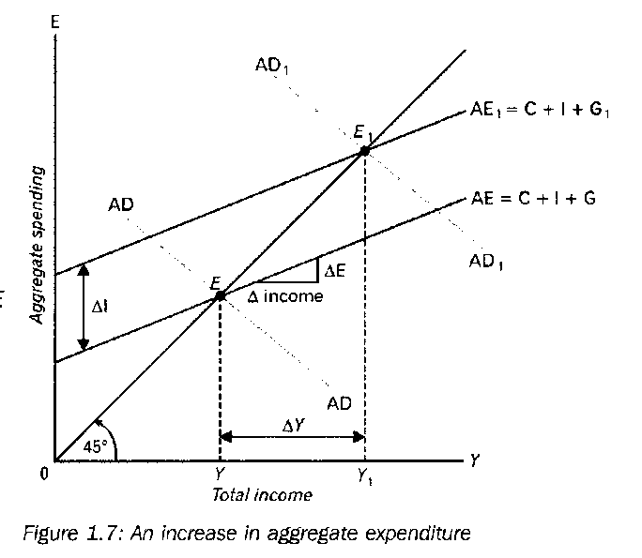

* **The above sketch:**
* AE = Aggregate Demand is illustrated by C + I + G
* ∆ I = ∆ G
* Government Investment increase
* The AE curve shifts to AE1
* The multiplier causes that Y increase to Y1
* If there is no reserve capacity in the economy

1. Prices will increase
2. Y (Income) will increase as a result of increased prices (inflation) and not as a result of more production output.

**Explain the Multiplier effect**

* The multiplier relates to how much national income changes as a result of an injection or withdrawal such as an investment.
* Initially there is an increase in injections into the economy (investment, government spending or export), which would lead to a proportionate increase in national income.
* The extra spending would have knock-on effect and create even more spending
* The size of the multiplier will depend on the level of leakages.
* (E.g.) assume firms increase investment spending by R1000. This is done by ordering capital goods from domestic firms to the value of R1000.
* Total spending has increased by R1000. Total production has increased by R1000, which also leads to an increase in R1000 in income. The increase in spending = the increase in production which = an increase in income.
* When households earn income (R1000) leakages can occur, through income

tax, savings and spending on imports.

* If this amounts to R300, then spending on domestic goods will increase by R700. At this stage the multiplier starts to kick in.