**ANSWERS**

1. Expansion is characterised by growth in real GDP and income. 

Consists of two phases – recovery and prosperity (also called the

boom).  (4)

 

1. Contraction is a period of gradual decline in economic activity. 

There is a decrease in aggregate demand that forces a decrease in output.  (4)

3.

* + JSE all share index
  + Money supply (M1)
  + Consumer price index
  + Factory hours worked opinion survey
  + Business cycle indicators of our major
  + trading partners
  + Manufacturing orders opinion survey
  + Inventory versus demand opinion survey (any 3 X 1)(3)

4.

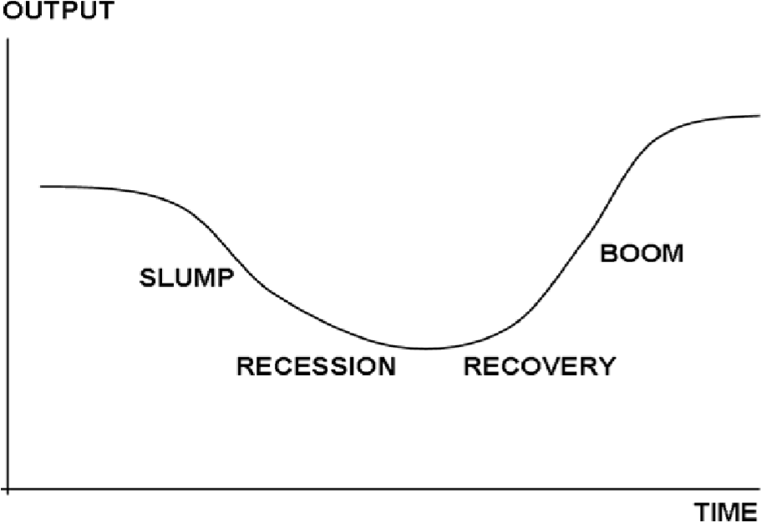 (4)

**Contraction phase**  is the downward phase of the business cycle. During this phase spending declines, gross domestic product falls, employment decreases, business confidence declines and income falls. 

**Trough**  is the point where the economic contraction is at its lowest. It is followed by an expansion. 

**Expansion phase**occurs when economic activity rises. This is reflected in an increase in spending, gross domestic product and employment.  

**Peak** is the point where the economic expansion is at its highest, after which it is followed by a contraction.

( 4 for diagram and 4 for note) (8)

5.

|  |  |
| --- | --- |
| Variable | Contraction phase |
| a) Gross domestic product | Decrease |
| b) Level of economic activity | Decrease |
| c) Total spending | Decrease |
| d) Level of production | Decrease |
| e) Consumer spending | Decrease |
| f) Investment confidence | Decrease |
| g) Investment spending | Decrease |
| h) Imports | Decrease |
| i) Inflation | Decrease |

(9)

1. During the upswing imports increase which negatively affects the balance of payments and leads to a depreciation of the exchange rate and an increase in the interest rate. These factors then impact negatively on the economy and a slow-down occurs. Or it might be that the increase in total spending leads to an increase in inflation, which negatively impacts on the level of economic activity. (8)

1. Exogenous factors are factors that have nothing to do with the business cycle such as

natural disasters or droughts. 

It is not possible to control these factors. 

Endogenous factors are factors within the business cycle such as changes in interest rates or changes in aggregate demand. 

These factors can be controlled to a certain degree.  (8)