REVISION
ELECTRICITY AND MAGNETISM: ELECTROSTATICS – MEMORANDUM

ONE-WORD ITEMS: COULOMB’S LAW, ELECTRIC FIELDS & POTENTIAL ENERGY
- Coulomb’s law
- Potential difference
- volt per meter or newton per coulomb
- volt

ONE-WORD ITEMS: CAPACITORS
- farad
- Capacitor
- Dielectric
- Capacitor

MULTIPLE CHOICE QUESTIONS: COULOMB’S LAW

- B 2. D 3. B 4. D
5. D 6. B 7. B 8. C
9. B

MULTIPLE CHOICE QUESTIONS: ELECTRIC FIELDS & POTENTIAL ENERGY
10. D 11. D 12. A 13. C
14. C 15. D 16. A 17. C

MULTIPLE CHOICE QUESTIONS: CAPACITORS
18. A 19. D 20. C 21. C
22. D 23. C 24. C 25. D
26. D

STRUCTURED QUESTIONS: COULOMB’S LAW, ELECTRIC FIELDS & POTENTIAL ENERGY

QUESTION 1

1.1 The magnitude of the electrostatic force exerted by one point charge on another point charge is directly proportional to the product of the magnitudes of the charges and inversely proportional to the square of the distance between them.

1.2 $F=\frac{{\text{kQ}}_{1}Q_{2}}{r^{2}}$
= $\frac{(9×{\text{10}}^{9})(5×{\text{10}}^{−9})(7×{\text{10}}^{−9})}{(\text{0,35})^{2}}$
= 2,57 x 10⁻⁶ N

1.3 ∆Q_{L} = Q_{L}(final) – Q_{L}(initial)
= 1 x 10⁻⁹ - 7 x 10⁻⁹
= 6 x 10-9 C
Number of electrons transferred = $\frac{6×{\text{10}}^{−9}}{1,6×{\text{10}}^{−\text{19}}}$ = 3,75 x 10¹⁰

QUESTION 2

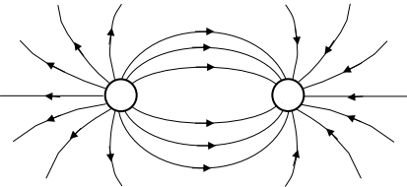
2.1
+
-
Criteria for electric field:
Kriteria vir elektriese veld:
Direction from positive to negative.
Rigting vanaf positief na negatief.
Shape as shown (do not penalise for density of field lines)./ Vorm soos getoon (moenie vir digtheid van veldlyne penaliseer nie).
Field lines not touching each other.
Veldlyne raak nie mekaar nie.

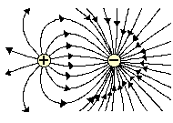
Note: If the quantity of charge on the two objects is not identical, the pattern will take on an asymmetric nature, as one of the objects will have a greater ability to alter the electrical nature of the surrounding space. The objects with the greater charge will have the greater number of lines emanating from it or approaching it.
2.2 The magnitude of the electrostatic force exerted by one point charge on another point charge is directly proportional to the product of the magnitudes of the charges and inversely proportional to the square of the distance between them.
2.3 $F=\frac{{\text{kQ}}_{1}Q_{2}}{r^{2}}$ = $\frac{(9×{\text{10}}^{9})(7×{\text{10}}^{−9})(6×{\text{10}}^{\text{-9}})}{(\text{0,15})^{2}}$ = 1,68 x 10⁻⁵ N
2.4 Attractive

QUESTION 3

3.1 The charge is 1 coulomb when a current of 1 ampere passes a point in a conductor in one second.
3.2 $F = \frac{\text{kQQ}}{r^{2}}$
$\begin{aligned} ∴ 0,9 = \frac{9 x {\text{10}}^{9} x Q_{A} x Q_{B}}{5×{\text{10}}^{−3}} \\ Q_{A} = Q_{B} = 7,\text{07} x {\text{10}}^{−7} C \end{aligned}$

QUESTION 4
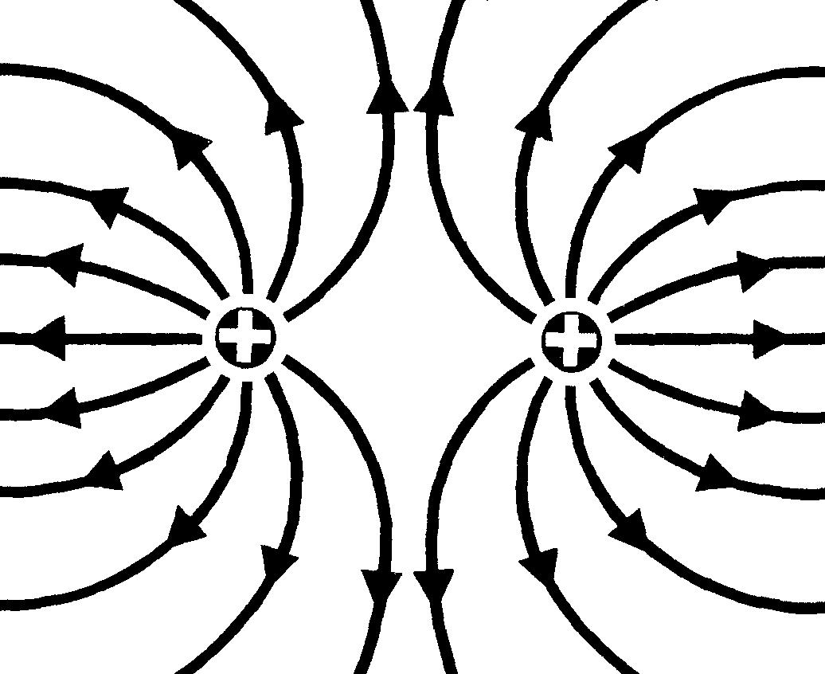
✓Pattern correct / Patroon korrek
✓Direction correct / Rigting korrek
If field lines do not touch object(s); -1 mark
As veldlyne nie aan voorwerpe raak nie; -1 punt
4.1

4.2 $F = \frac{\text{kQQ}}{r^{2}}$
$$\begin{aligned} ∴ \text{23},\text{04} x {\text{10}}^{−1} = \frac{9 x {\text{10}}^{9} x Q_{A} x Q_{B}}{0,{\text{010}}^{2}} \\ Q^{2} = 2,\text{56} x {\text{10}}^{−\text{14}} \\ Q_{A} = Q_{B} = 1,6 x {\text{10}}^{−7} C \end{aligned}$$
QUESTION 5

5.1 The net electric charge in an isolated system remains constant during any process.
OR
Charge cannot be created or destroyed, but can only be transferred from one object to another.

5.2
+
-
Criteria for electric field:
Kriteria vir elektriese veld:
Direction from positive to negative.
Rigting vanaf positief na negatief.
Shape as shown (do not penalise for density of field lines)./ Vorm soos getoon (moenie vir digtheid van veldlyne penaliseer nie).
Field lines not touching each other.
Veldlyne raak nie mekaar nie.

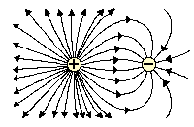
Note: If the quantity of charge on the two objects is not identical, the pattern will take on an asymmetric nature, as one of the objects will have a greater ability to alter the electrical nature of the surrounding space. The objects with the greater charge will have the greater number of lines emanating from it or approaching it.

5.3 Force of attraction
5.4 Q = $\frac{−5×{\text{10}}^{−6} + 9×{\text{10}}^{−6}}{2}$ = 2 x 10⁻⁶ C
5.5 $F=\frac{{\text{kQ}}_{1}Q_{2}}{r^{2}}$
= $\frac{(9×{\text{10}}^{9})(2×{\text{10}}^{−6})(2×{\text{10}}^{−6})}{(\text{0,5})^{2}}$
= 1,44 x 10⁻¹ N (0,144 N)

5.6 Four times larger i.e. 0,576 N

QUESTION 6

6.1
-
Criteria for electric field
Direction of field (towards charge)
Shape (Field radially symmetrical)

6.2 $n_{\text{electrons}}=\frac{Q}{q_{e}}$
= $\frac{−4×{\text{10}}^{−9}}{−1,6×{\text{10}}^{−\text{19}}}$ OR $\frac{4×{\text{10}}^{−9}}{1,6×{\text{10}}^{−\text{19}}}$
= 2,5 x 10¹⁰ (electrons)

6.3 $F=\frac{{\text{kQ}}_{1}Q_{2}}{r^{2}}$ = $\frac{(9×{\text{10}}^{9})(4×{\text{10}}^{−9})(2×{\text{10}}^{−9})}{(1×{\text{10}}^{−2})^{2}}$ = 7,2 x 10⁻⁴ N

6.4 New charge = $\frac{(−4×{\text{10}}^{−9})+(2×{\text{10}}^{−9})}{2}$
= -1 x 10⁻⁹ C
$U=\frac{{\text{kQ}}_{1}Q_{2}}{r}$ = $\frac{(9×{\text{10}}^{9})(−1×{\text{10}}^{−9})(−1×{\text{10}}^{−9})}{(1×{\text{10}}^{−2})}$
= 9 x 10⁻⁷ J

QUESTION 7

7.1 T to/na P
7.2 Q = $\frac{3×{\text{10}}^{−9} + (−6×{\text{10}}^{−9})}{2}$ = -1,5 x 10⁻⁹ C
$Δ$Q_{P} = Q_{P}(final) – Q_{P}(initial)
= -1,5 x 10⁻⁹ – 3 x 10⁻⁹
= -4,5 x 10⁻⁹ C

OR / OF
$Δ$Q_{T} = Q_{T}(final) – Q_{T}(initial)
= -1,5 x 10⁻⁹ – (-6 x 10⁻⁹)
= 4,5 x 10⁻⁹ C
7.3 Number of electrons / Getal elektrone = $\frac{−4,5×{\text{10}}^{−9} }{−1,6×{\text{10}}^{−\text{19}}}$
= 2,81 x 10¹⁰
7.4 F_{TR} = $\frac{{\text{kQ}}_{1}Q_{2}}{r^{2}}$
= $\frac{(9×{\text{10}}^{9})(1,5×{\text{10}}^{−9})(3×{\text{10}}^{−9})}{1^{2}}$
= 4,05 x 10⁻⁸ N to the left/towards P / Na links/na P toe
F_{PR} = $\frac{{\text{kQ}}_{1}Q_{2}}{r^{2}}$
= $\frac{(9×{\text{10}}^{9})(1,5×{\text{10}}^{−9})(3×{\text{10}}^{−9})}{{0,5}^{2}}$
= 1,62 x 10⁻⁷ N to the right/towards T/ Na regs/na T toe

To the right / towards T as positive: / Na regs / na T toe as positief
F_{net} = 1,62 x 10⁻⁷ - 4,05 x 10⁻⁸
= 1,22 x 10⁻⁷ N (1,215 x 10⁻⁷ N)
= 1,22 x 10⁻⁷ N to the right / towards T / na regs / na T toe

QUESTION 8

8.1 Electric) force experienced per (positive) charge placed at the point.
(Elektriese) krag ondervind per (positiewe) lading geplaas by die punt.

8.2
+
-
Criteria for electric field:
Kriteria vir elektriese veld:
Direction from positive to negative.
Rigting vanaf positief na negatief.
Shape as shown (do not penalise for density of field lines)./ Vorm soos getoon (moenie vir digtheid van veldlyne penaliseer nie).
Field lines not touching each other.
Veldlyne raak nie mekaar nie.

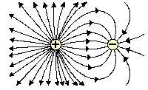
Note: If the quantity of charge on the two objects is not identical, the pattern will take on an asymmetric nature, as one of the objects will have a greater ability to alter the electrical nature of the surrounding space. The object with the greater charge will have the greater number of lines emanating from it or approaching it. Therefore a more correct electric field pattern is as shown alongside.

8.3 Electric field at P due to Q₁:/Elektriese veld by P as gevolg van Q₁:
E = $\frac{\text{kQ}}{r^{2}}$ = $\frac{9 × {\text{10}}^{9} × \text{14} × {\text{10}}^{−6}}{1^{2}}$= 1,26 x 10⁵ N∙C⁻¹ to the left/na links

Electric field at P due to Q₂: Elektriese veld by P as gevolg van Q₂:
E = $\frac{\text{kQ}}{r^{2}}$ = $\frac{9 × {\text{10}}^{9} × \text{20} × {\text{10}}^{−6}}{2^{2}}$= 4,5 x 10⁴ N∙C⁻¹ to the left/na links

E_{net} = 1,26 x 10⁵ + 4,5 x 10⁴ N∙C⁻¹
= 1,71 x 10⁵ N∙C⁻¹ to the left/na links

QUESTION 9

9.1 $F=\frac{{\text{kQ}}_{1}Q_{2}}{r^{2}}$
= $\frac{(9×{\text{10}}^{9})(4×{\text{10}}^{−6})(6×{\text{10}}^{−6})}{(\text{0,4})^{2}}$
= 1,35 N

9.2 Four/vier/4

9.3 E(6 $μ$C) = $\frac{\text{kQ}}{r^{2}}$= $\frac{(9×{\text{10}}^{9})(6×{\text{10}}^{−6})}{(\text{0,2})^{2}}$ = 1,35 x 10⁶ N·C⁻¹ to the left/na links

E(4 $μ$C) = $\frac{\text{kQ}}{r^{2}}$ = $\frac{(9×{\text{10}}^{9})(4×{\text{10}}^{−6})}{(\text{0,6})^{2}}$ = 1 x 10⁵ N·C⁻¹ (to the right / na regs)
To the right as positive/Na regs as positief:
E_{net/netto} = - 1,35 x 10⁶ + 1 x 10⁵ = - 1,25 x 10⁶ N·C⁻¹

E_{net/netto} = 1,25 x 10⁶ N·C⁻¹ to the left / na links

9.4 New charge/Nuwe lading = $\frac{(+4×{\text{10}}^{−6})+(−6×{\text{10}}^{−6})}{2}$
= -1 x 10⁻⁶ C or/of – 1 $μ$C
$U = \frac{{\text{kQ}}_{1}Q_{2}}{r}$
= $\frac{(9×{\text{10}}^{9})(− 1×{\text{10}}^{−6})(− 1×{\text{10}}^{−6})}{(0,4)}$
$∴$ U = 2,25 x 10⁻² J (0,02 J)

QUESTION 10

10.1 E_{P} = $\frac{\text{kQ}}{r^{2}}$= $\frac{(9×{\text{10}}^{9})(8×{\text{10}}^{−9})}{(0,\text{01})^{2}}$ = 7,2 x 10⁵ N∙C⁻¹ towards P
E_{Q} = $\frac{\text{kQ}}{r^{2}}$= $\frac{(9×{\text{10}}^{9})(\text{16}×{\text{10}}^{−9})}{(0,\text{01})^{2}}$ = 1,44 x 10⁶ N∙C⁻¹ towards P
Towards P as positive:
E_{net} = 7,2 x 10⁵ + 1,44 x 10⁶ = 2,16 x 10⁶ N∙C⁻¹ (towards P)

10.2 E = $\frac{F}{q}$
$∴$ 2,16 x 10⁶ = $\frac{F}{1,6×{\text{10}}^{−\text{19}}}$
$∴$F = 3,46 x 10⁻¹³ N

10.3 Q = $\frac{−8×{\text{10}}^{−9} + \text{16}×{\text{10}}^{−9}}{2}$ = 4 x 10⁻⁹ C

10.4 $Δ$Q_{P} = Q_{P}(final) – Q_{P}(initial)
= 4 x 10⁻⁹ – (-8 x 10⁻⁹)
= 12 x 10⁻⁹ C
OR/OF
$Δ$Q_{Q} = Q_{Q}(final) – Q_{Q}(initial)
= 4 x 10⁻⁹ – 16 x 10⁻⁹
= 12 x 10⁻⁹ C
10.5 The magnitude of the electrostatic force exerted by one point charge on another point charge is directly proportional to the product of the magnitudes of the charges and inversely proportional to the square of the distance between them.

10.6 F(original) α (8)(16) = 128
F(after) α (4)(4) = 16
F decreases from 128 i.e. (16 x 8) to 16
Factor: 8

QUESTION 11
11.1 The (electrostatic) force experienced at a point per unit charge at that point.
Die elektrostatiese krag ondervind by 'n punt per eenheidslading by daardie punt.

11.2
✓Pattern correct / Patroon korrek
✓Direction correct / Rigting korrek
If field lines do not touch object(s); -1 mark
As veldlyne nie aan voorwerpe raak nie; -1 punt

11.3 E_{P} = $\frac{\text{kQ}}{r^{2}}$= $\frac{(9×{\text{10}}^{9})(5×{\text{10}}^{−9})}{(\text{30}×{\text{10}}^{−3})^{2}}$ = 5 x 10⁴ N∙C⁻¹ to the right/na regs
E_{Q} = $\frac{\text{kQ}}{r^{2}}$= $\frac{(9×{\text{10}}^{9})(5×{\text{10}}^{−9})}{(\text{10}×{\text{10}}^{−3})^{2}}$ = 4,5 x 10⁵ N∙C⁻¹ to the right/na regs
E_{net} = 5 x 10⁴ + 4,5 x 10⁵ = 5 x 10⁵ N∙C⁻¹ to the right/na regs

11.4 $E=\frac{F}{q}$
$∴$5 x 10⁵ = $\frac{F}{1,6×{\text{10}}^{−\text{19}}}$
$∴$F = 8 x 10⁻¹⁴ N

QUESTION 12

12.1 Electric potential difference is the work done per unit charge in moving the charge between two points in an electric field.
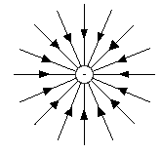
12.2

12.3 E = $\frac{\text{kQ}}{r^{2}}$= $\frac{(9×{\text{10}}^{9})(\text{14}×{\text{10}}^{−6})}{(0,5)^{2}}$ = 5,04 x 10⁵ N∙C⁻¹ towards the charge

12.4 $U=k\frac{Q_{1}Q_{2}}{r}$ = $\frac{(9×{\text{10}}^{9})(−\text{14}×{\text{10}}^{−6})(8×{\text{10}}^{−6})}{6×{\text{10}}^{−3}}$ = - 168 J

CONTEXTUAL QUESTIONS: CAPACITORS

QUESTION 13

13.1 Dielectric / Diëlektrikum
Distance between plates / Afstand tussen plate

13.2
+
-
13.2.1
Checklist / Kontrolelys
Evenly spaced field lines.  Eweredig gespasieerde veldlyne. | ✓
Direction of field lines from positive to negative.  Rigting van veldlyne vanaf positief na negatief. | ✓
Field lines curved at the ends.  Veldlyne gekrom by die ente. | ✓

13.2.2 C = $\frac{ε_{0}A}{d}$ = $\frac{(8,\text{85} × {\text{10}}^{−\text{12}})(2 × {\text{10}}^{−2})(\text{10}×{\text{10}}^{−2}) }{0,2 ×{\text{10}}^{−3}}$ = 8,85 x 10⁻¹¹ F
13.2.3 C = $\frac{Q}{V}$ $∴$8,85 x 10⁻¹¹ = $\frac{Q}{\text{20}}$ $∴$Q = 1,77 x 10⁻⁹ C

QUESTION 14

14.1 Electric) force experienced per (positive) charge placed at the point.
(Elektriese) krag ondervind per (positiewe) lading geplaas by die punt

14.2 Negative/Negatief
Negative ink droplets deflect away from B. / are attracted towards A. / repels P.
Negatiewe inkdruppels word vanaf B gedeflekteer. / word deur A aangetrek. / stoot P af.
+ or A
- or B
14.3
Checklist / Kontrolelys
Evenly spaced field lines.  Eweredig gespasieerde veldlyne. | ✓
Direction of field lines from positive to negative.  Rigting van veldlyne vanaf positief na negatief. | ✓
Field lines curved at the ends.  Veldlyne gekrom by die ente. | ✓

14.4 $E=\frac{F}{q}$ = $\frac{2,1×{\text{10}}^{−7}}{1,5×{\text{10}}^{−\text{13}}}$ = 1,4 x 10⁶ NC⁻¹
$E=\frac{V}{d}$ $∴$ $1,4×{\text{10}}^{6}$=$\frac{V}{6,4×{\text{10}}^{−4}}$
$∴$V = 8,96 x 10² V
OR/OF
$V=\frac{\text{Fd}}{q}$ = $\frac{(2,1×{\text{10}}^{−7})(6,4×{\text{10}}^{−4})}{1,5×{\text{10}}^{−\text{13}}}$ = 8,96 x 10² V

QUESTION 15

15.1 Discharges very fast when touched and can cause electric shock (that can be fatal).
Ontlaai baie vinnig wanneer aangeraak word en kan 'n (dodelike) elektriese skok tot gevolg hê.
15.2 $C=\frac{ε_{o}A}{d}$ = $\frac{(\text{8,85}×{\text{10}}^{−\text{12}})(2×{\text{10}}^{−4})}{(\text{0,03}×{\text{10}}^{−3})}$
$∴$ C = 5,9 x 10⁻¹¹ F

15.3 $C=\frac{Q}{V}$ $∴$Q = 5,9 x 10⁻¹¹ x 6 $∴$Q = 3,54 x 10⁻¹⁰ C
15.4
15.4.1 Increases
15.4.2 Decreases

QUESTION 16

16.1 The ratio of the (amount of) charge (transferred) to the (resulting) potential difference.

16.2 C = $\frac{ε_{0}A}{d}$ = $\frac{(8,\text{85} × {\text{10}}^{−\text{12}})(2 × {\text{10}}^{−3})(1,5 × {\text{10}}^{−3})}{1,5×{\text{10}}^{−3}}$
$∴$C = 1,77 x 10⁻¹² F (1,77 pF)

16.3
I (A)
t(s)

16.4 C = $\frac{Q}{V}$
$∴$1,77 x 10⁻¹² = $\frac{Q}{\text{12}}$
$∴$ Q = 2,12 x 10⁻¹¹ C

16.5 F = $\frac{\text{Vq}}{d}$= $\frac{(\text{12})(3,2×{\text{10}}^{−\text{19}})}{1,5×{\text{10}}^{−3}}$ = 2,56 x 10⁻¹⁵ N

OR/OF

E = $\frac{V}{d}$ = $\frac{\text{12}}{1,5 ×{\text{10}}^{−3}}$ = 8 x 10³ V·m⁻¹

$E= \frac{F}{q}$ $∴$8 x 10³ = $\frac{F}{3,2×{\text{10}}^{−\text{19}}}$
$∴$F = 2,56 x 10⁻¹⁵ N

QUESTION 17

17.1 The amount of charge stored per unit potential difference.

17.2 $C = \frac{Q}{V}$ $∴$$\text{10} x {\text{10}}^{−6} = \frac{Q}{2 \text{100}}$
$∴$$Q = 2,1 x {\text{10}}^{−2} C (0,\text{021} C)$

17.3 $C = \frac{ε_{∘}A}{d}$
$\begin{aligned}\text{10} x {\text{10}}^{−6} = \frac{8,\text{85} x {\text{10}}^{−\text{12}} x A}{0,\text{0001}} \\ A = 1,\text{13} x {\text{10}}^{2} m^{2} (\text{113} m^{2})\end{aligned}$

17.4 The dielectric becomes polarised when it is inserted in the gap.
An electric field is induced in the dielectric, which opposes the field between the plates.
The electric field between the plates therefore decreases, causing the potential difference across the plates to decrease.

QUESTION 18

18.1 The amount of charge stored per unit potential difference.
18.2 E = $\frac{V}{d}$ = $\frac{\text{1000}}{0,\text{008}}$ = 1, 25 x 10⁵ V·m⁻¹
18.3 $C = \frac{ε_{∘}A}{d}$ = $\frac{(8,\text{85} x {\text{10}}^{−\text{12}} )( 0,\text{04})}{8×{\text{10}}^{{}_{−3}}}$ = 4,43 x 10⁻¹¹ F
18.4 No effect

18.5 E = 3(1, 25 x 10⁵ V·m⁻¹) = 3,75 x 10⁵ V·m⁻¹
OR
E = $\frac{V}{d}$ = $\frac{\text{3000}}{0,\text{008}}$ = 3,75 x 10⁵ V·m⁻¹
F_{net} = ma
Eq = ma
$∴$a = 6,60 x 10¹⁶ m·s⁻²

QUESTION 19

19.1 $E = \frac{V}{d} = \frac{8 \text{000}}{0,\text{032}} = 2,5 x {\text{10}}^{5} V⋅m^{−1}$ positive to negative

19.2 Lower plate is positive. Electrons flow from carbon particles to plate. Carbon particles become positively charged.

19.3 Repelled by upper plate OR accelerate downwards.
When the carbon particles touch the upper plate, electrons flow from the plate to
the carbon particles. Carbon particles become negatively charged.

QUESTION 20
20.1 I = $\frac{V}{R}$ = $\frac{9}{5×{\text{10}}^{3}}$ = 1,8 x 10⁻³ A
20.2 3 V
20.3 I = $\frac{V}{R}$ = $\frac{3}{5×{\text{10}}^{3}}$ = 6 x 10⁻⁴ A
20.4 18.5
I (A)
t(s)
V (V)
t(s)

20.6 $C = \frac{Q}{V}$
$∴$$1 x {\text{10}}^{−6} = \frac{Q}{9}$
$∴$Q = 9 x 10⁻⁶ C

20.7 0 A

QUESTION 21

21.1
+

+

+

+

-

-

-

-
Checklist / Kontrolelys
Evenly spaced field lines.  Eweredig gespasieerde veldlyne. | ✓
Direction of field lines from positive to negative.  Rigting van veldlyne vanaf positief na negatief. | ✓
Field lines curved at the ends.  Veldlyne gekrom by die ente. | ✓

21.2 Electric field E between parallel plates is uniform.
From F = Eq it follows that the force F will be constant for an electron (q = constant).
From F_{net} = ma it follows that the acceleration a will be constant for an electron (m = constant).
21.3 W = Vq = ½mv²
$∴$(500)(1,6 x 10⁻¹⁹) = ½(9,11 x 10⁻³¹)v²
$∴$ v = 1,33 x 10⁷ m∙s⁻¹

QUESTION 22

22.1 $C=\frac{ε_{o}A}{d}$ =$\frac{(8,\text{85}×{\text{10}}^{−\text{12}})(\text{40} x {\text{10}}^{−4})}{(0,\text{01})}$ = 3,54 x 10⁻¹² F

Q = CV
= (3,54 x 10⁻¹²)(12)
= 4,25 x 10⁻¹¹ C

22.2 Half / Helfte
Half the area will store half the amount of charge. / Helfte van die oppervlak sal helfte van die lading stoor.
C $α$ Q, (thus C is halved / dus is C gehalveer)
OR/OF
half / Helfte
C $α$ A and/en C $α$ Q, thus/dus Q $α$ A

22.3 net charge / netto lading = 0 C

22.4 Discharges almost instantly to deliver a flash light.
Ontlaai feitlik onmiddellik om 'n flits te lewer.

QUESTION 23

23.1 $R = \frac{V}{I}$
1 000 = $\frac{\text{12}}{I}$
$∴$I = 0,01(2) A

23.2 12 V
23.3 C = $\frac{Q}{V}$
120 x 10⁻⁶ = $\frac{Q}{\text{12}}$
$∴$Q = 1,44 x 10⁻³ C

23.4
23.4.1 Decreases/Verminder
23.4.2 Increases/Vermeerder

23.5
+
-
23.5.1
Criteria for sketch:
Parallel lines equally spaced. | 
Direction from positive plate towards negative plate.(Polarity of plates must be indicated) | 
Field curved at the ends of the plates. | 

23.5.2 E = $\frac{V}{d}$
= $\frac{\text{12}}{\text{12}×{\text{10}}^{−3}}$
$∴$E = 1 000 V∙m⁻¹
QUESTION 24

24.1 Stores (electric) charge/energy.
OR
Releases (stored) charge instantly/very fast. 
24.2 The brightness of the bulb decreases (gradually) until it stops glowing/dies.
OR
The bulb glows dimmer until it stops glowing/dies.
24.3
24.3.1 0 (V)
24.3.2 12 V

24.4
24.4.1 E = $\frac{V}{d}$
= $\frac{\text{12}}{5,4×{\text{10}}^{−3}}$
= 2,22 x 10³ V·m⁻¹
24.4.2 $E=\frac{F}{q}$
$∴$2,22 x 10³ = $\frac{F}{1,6×{\text{10}}^{−\text{19}}}$
$∴$F = 3,56 x 10⁻¹⁶ N
24.5
24.5.1 5,4 mm – 3,8 mm = 1,6 mm
24.5.2 W = FΔxcosθ
= (3,56 x 10⁻¹⁶)(1,6 x 10⁻³)cos 0°
= 5,69 x 10⁻¹⁹ J

