**Life Sciences Assessment HOMEOSTATIC CONTROL OF GLUCOSE December 2020**  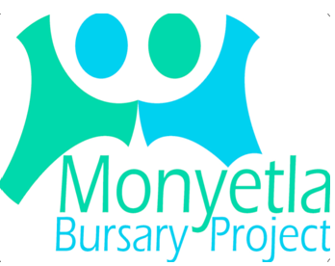

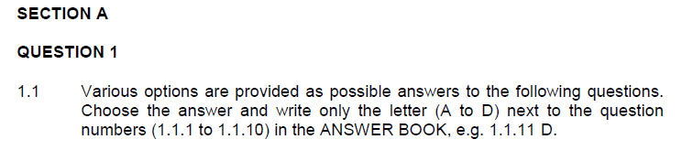

* + 1. Chemical messengers that travel in the blood and affect target organs are

A enzymes.

B biological catalysts.

C hormones.

D glycoproteins.

* + 1. The hormone that causes a greater concentration of glycogen in the liver is

A insulin.

B glucagon.

C islets of Langerhans.

D glycogen.

1.1.3 The medical condition that refers to chronic uncontrolled blood sugar levels is

A diabetes mellitus. B type 1 diabetes only. C type 2 diabetes only. D hypertension. **3 x 2 (6)**



1.2.1 The collective process of maintaining a constant internal environment. 1.2.2 Organs that are stimulated by hormones. 1.2.3 Glands that secrete hormones. 1.2.4 The process whereby one hormone inhibits the functioning of another. 1.2.5 Converted glucose stored in the liver. 1.2.6 The hormone which has an opposite effect to insulin. 1.2.7 The hormone responsible for reducing the [blood glucose]. 1.2.8 The endocrine gland responsible for the homeostatic control of glucose. **(8)**

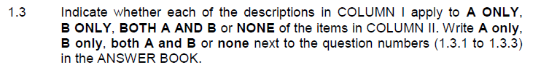

|  |  |
| --- | --- |
| **COLUMN I** | **COLUMN II** |
| 1.3.1 Insulin resistant diabetes. | A: Type 1 diabetes  B: Type 2 diabetes |
| 1.3.2 Organ(s) involved in the homeostatic control of glucose. | A: Liver  B: Pancreas |
| 1.3.3 End product in the digestion of starch | A: Amino acids  B: Glucose |

**3 x 2 (6)**

**SECTION A: 20**

**SECTION B**

**QUESTION 2**

2.1 Examine the diagram below of the homeostatic control of glucose and answer the questions that follow.

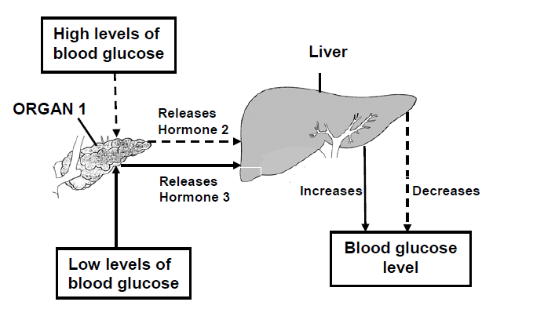

2.1.1 Explain why ORGAN 1 is known as an endocrine gland. (2)

2.1.2 Name the hormones 2 and 3. (2)

2.1.3 Describe the role of hormone 2 in the homeostatic control of glucose. (6)

2.1.4 Explain the concept of negative feedback by referring to the diagram above. (5)

**[15]**

**QUESTION 3.3** (From NSC P1 – 2018)

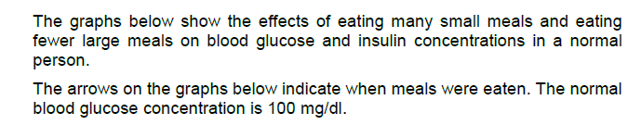

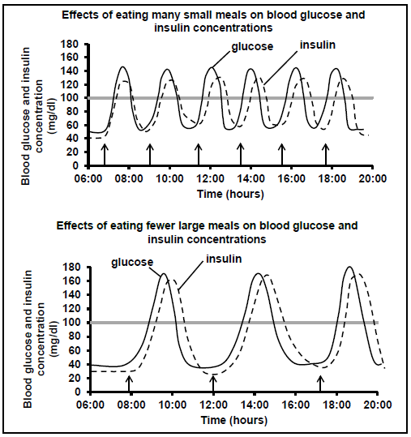

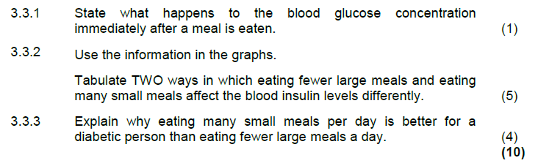

3.4 Examine the graphs below and answer the questions that follow.

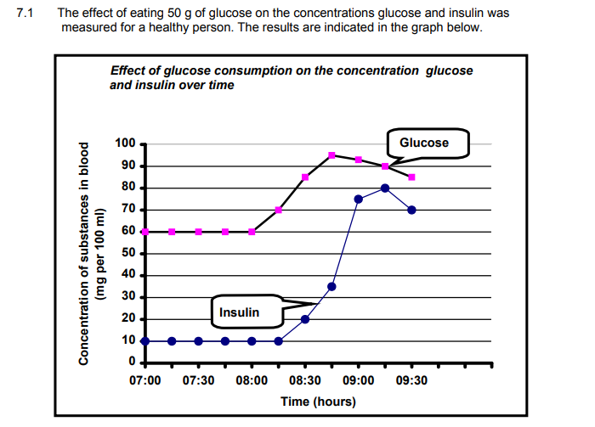

3.4.1 When did the person consume the glucose? (1)

3.4.2 Provide a reason for the secretion of insulin at 8:15. (2)

3.4.3 Calculate the percentage increase in [blood glucose] in the 45 minute period following the consumption of glucose. (2)

(**5)**

**[15]**

**TOTAL: 50**