**Life Sciences Assessment Scientific Investigation December 2020**  

**Question 1**

A grade 11 learner was assigned to investigate the effect of temperature on the growth rate of pea plants *(Pisum sativum).* She planted 10 seeds in potting soil and kept the young plants in the Life Sciences classroom. She controlled the temperature of the room by closing all doors and windows and regulated the temperature by using an air conditioner. The duration of the investigation was 5 days. Every day she increased the temperature. The learner measured the length of the stems and compiled the following table of results.

|  |  |  |  |  |  |
| --- | --- | --- | --- | --- | --- |
| Temperature in the room (°C) | 20 | 25 | 30 | 35 | 40 |
| Average length of the stems (mm) | 15 | 18 | 20 | 21 | 21 |
| Day | 1 | 2 | 3 | 4 | 5 |

1.1 Provide a suitable heading for the table. (2)

1.2 Write a hypothesis for the investigation. (2)

1.3 Identify the independent variable in the experiment above. (1)

1.4 How can the learner ensure the validity of the experiment? (3)

1.5 How can she make the results more reliable? (3)

1.6 Calculate the **percentage increase** in the average length of stems from day 1 to day 2. (Show all working) (3)

**[14]**

**Question 2 (Adapted from NSC Paper 1 – 2016)**

A scientist did an investigation on a healthy individual to determine the effect of drinking water on urine production. The participant was requested not to eat or drink 4 hours before the investigation. The investigation was conducted over a period of 3 days.

The procedure was as follows:

* On day 1 the participant was given 600 ml of water to drink.
* On day 2 the participant was given 800 ml of water to drink.
* On day 3 the participant was given 1000 ml of water to drink.
* For each day the amount of urine produced by the participant was measured and recorded over the next 4 hours, an average was calculated.

2.1 Which of the following are considered to be planning steps?

(i) Permission was obtained to participate in the

investigation.

(ii) The measuring tool to be used was decided upon.

(iii) Water was given to the participant to drink.

(iv) The amount of urine produced was measured. (2)

2.2 Describe TWO precautions to be taken in this investigation. (4)

2.3 Draw a line graph to indicate the influence of temperature

on the growth of *Pisum sativum.* (6)

**[12]**

**Question 3 (Adapted from NSC Paper 1 2018)**

Study the graph and then answer the questions that follow:

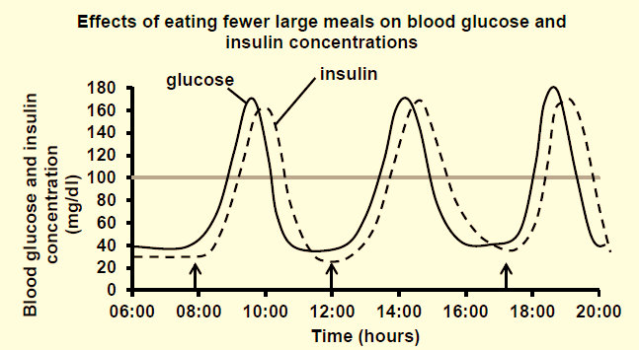

* 1. Use the graph to determine the time of the day when the

blood glucose concentration is at a minimum. (1)

* 1. Use the graph to describe the relationship between blood

glucose concentration and insulin concentration. (2)

* 1. If 100mg/dl glucose concentration is normal for blood

glucose levels, how long does it take for the person’s glucose concentration to be back to normal after the effects of the 12:00 lunch? (3)

* 1. The first peak of the day for blood glucose concentration

is at 9:45. Provide an explanation why the first peak for insulin concentration is at 10:00? (4)

* 1. Calculate the increase in blood glucose concentration

from the first meal of the day until the first peak in glucose concentration. (Show all working) (4)

**[14]**

**Question 4 (Adapted from NSC Paper 1 – 2018) [10]**

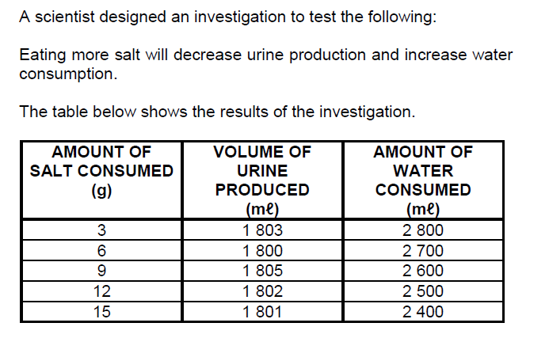

4.1 Provide a hypothesis to describe the influence of salt consumption on the volume of urine produced. (2)

4.2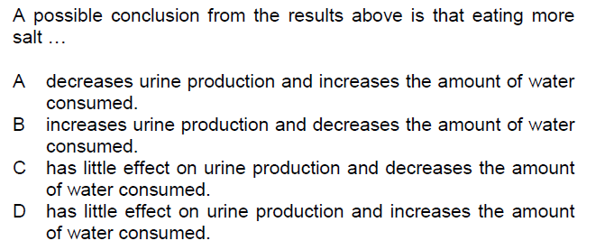

(2)

4.3 Calculate the average urine production when 3g, 6g and 9g of salt was consumed. (Show all working) (3) 4.4 How can the reliability of the investigation be improved? (2) 4.5 Name ONE dependent variable in this investigation. (1)  **TOTAL: 50**