**SCIENTIFIC INVESTIGATION SKILLS**

THE SKILLS REQUIRED IN LIFE SCIENCES FOR THE NSC EXAMS ARE INDICATED IN RED.

INTERPRETING GRAPHS AND DATA

**NOVEMBER 2016**

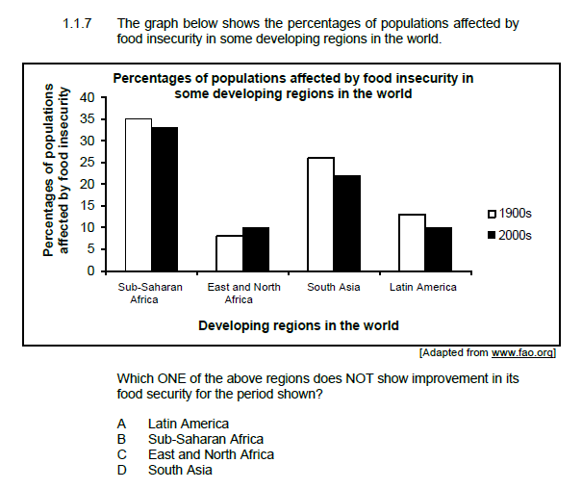

**IDENTIFY VARIABLES**

* INDEPENDENT VARIABLE
* DEPENDENT VARIABLE
* CONTROLLED VARIABLES

Example, an investigation was conducted to determine the effect of brightness of light on the diameter of the pupil of the eye.

**BE ABLE TO WRITE…**

* HYPOTHESIS
* INVESTIGATIVE QUESTION
* CONCLUSION
* PLANNING
* PRECAUTIONS

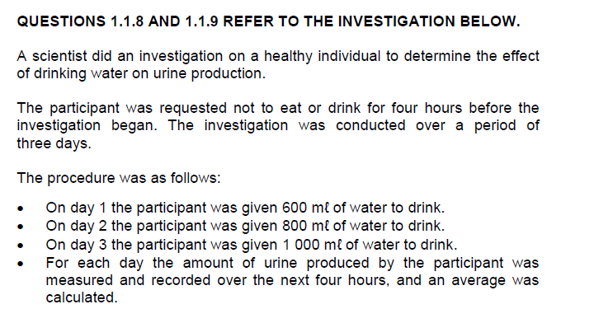

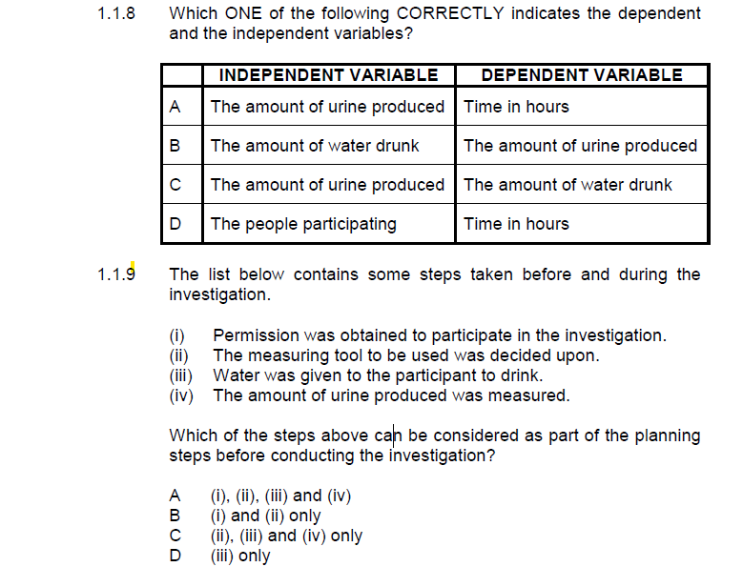

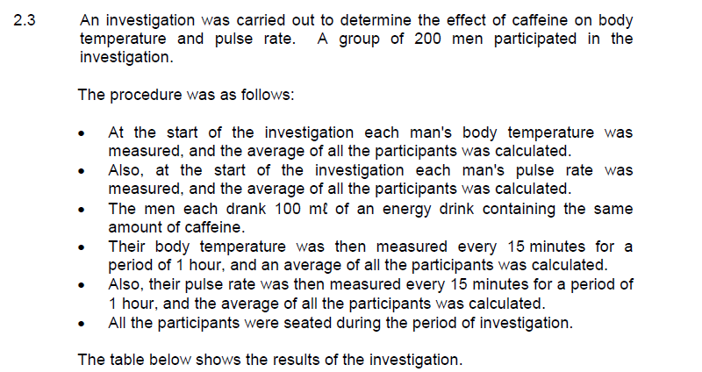

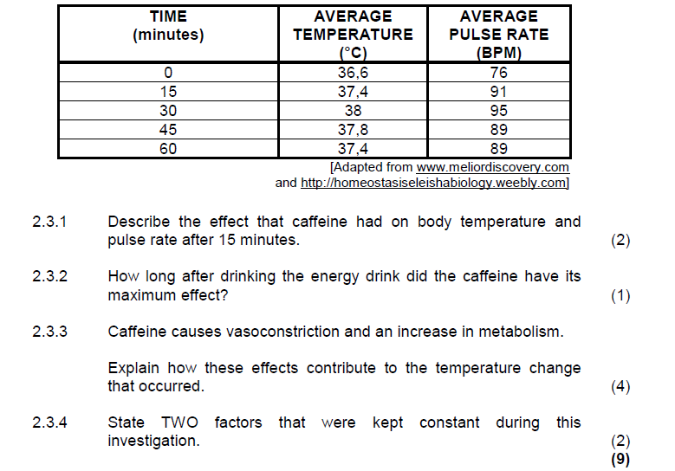

SIMPLE CALCULATIONS

* AVERAGE
* DIFFERENCE
* %
* % INCREASE
* HOW MANY TIMES BIGGER

**Example, the growth rate of a certain plant per day.**

|  |  |  |  |  |  |
| --- | --- | --- | --- | --- | --- |
| **Day** | 1 | 2 | 3 | 4 | 5 |
| **Growth in cm/day** | 0,5 | 1,2 | 2,5 | 0,75 | 0,75 |

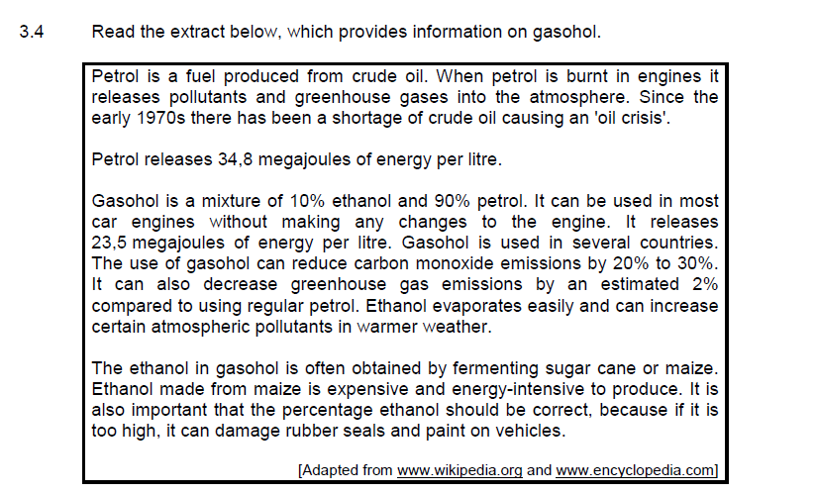

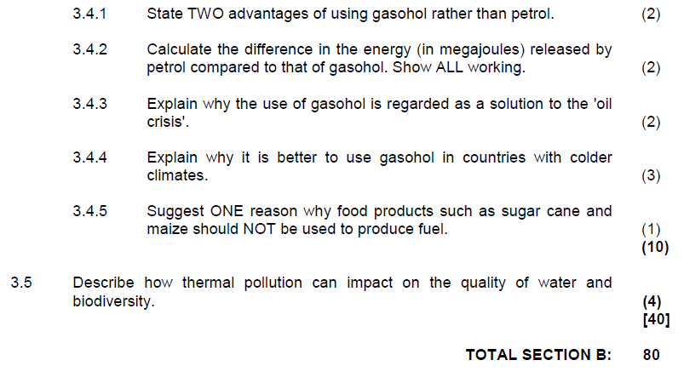

NOVEMBER 2017

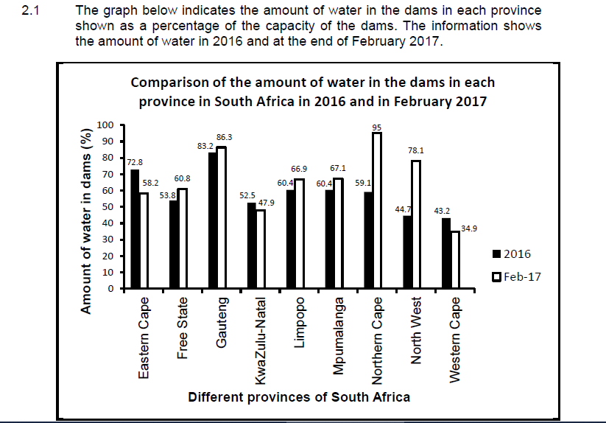

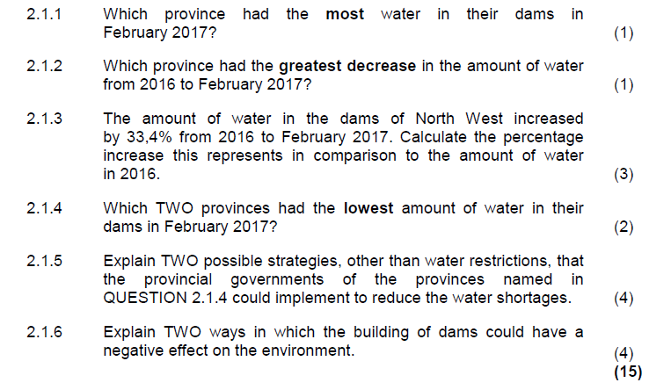

DRAW DIAGRAMS

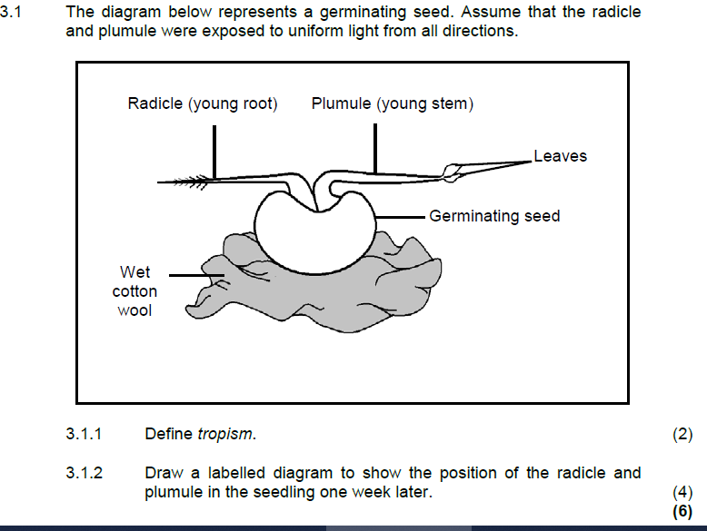

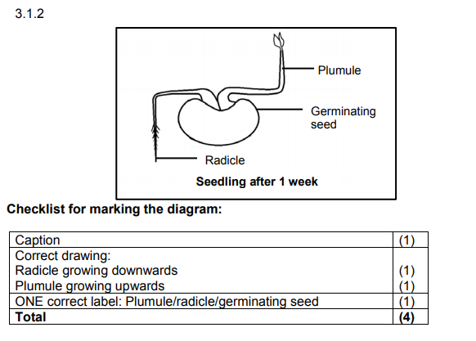

RELIABILITY AND VALIDITY

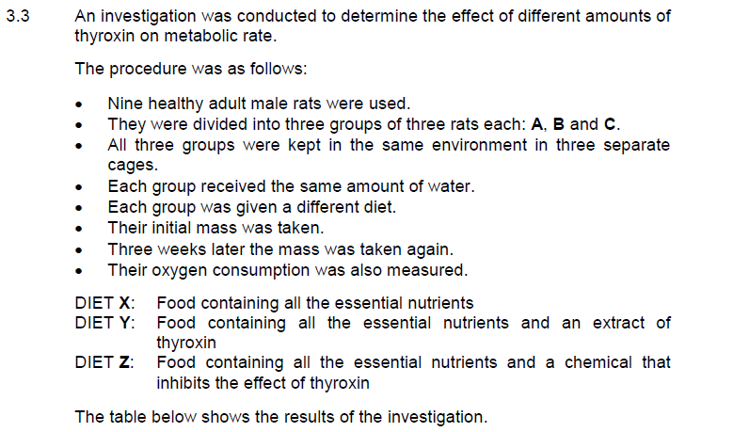

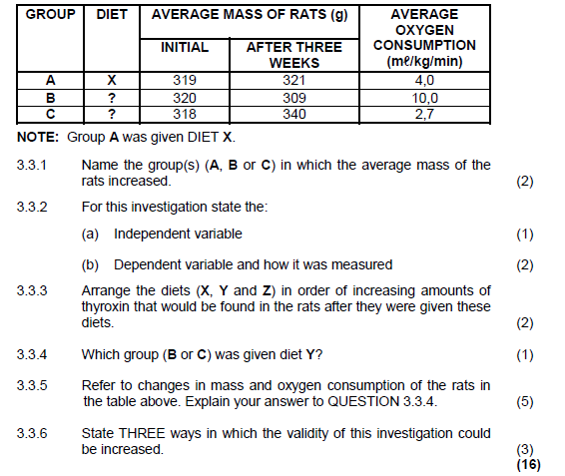

NOVEMBER 2018

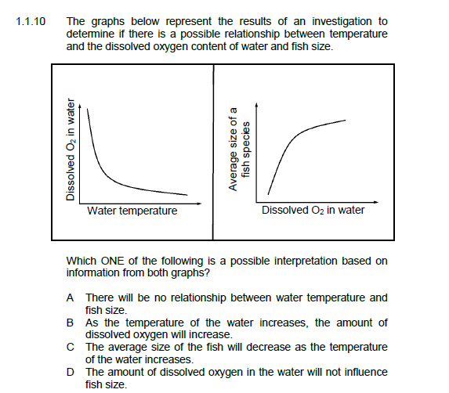

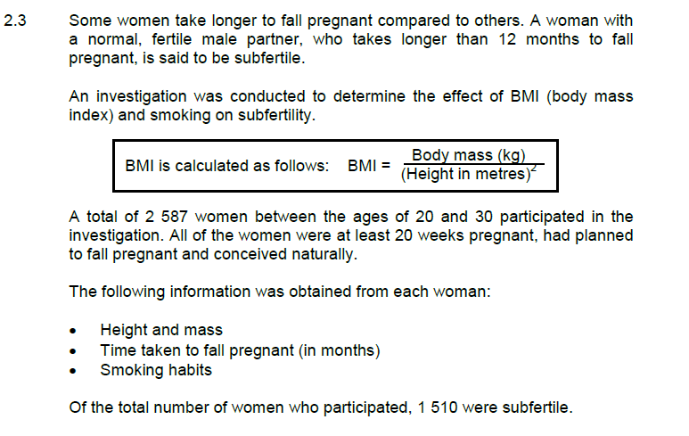

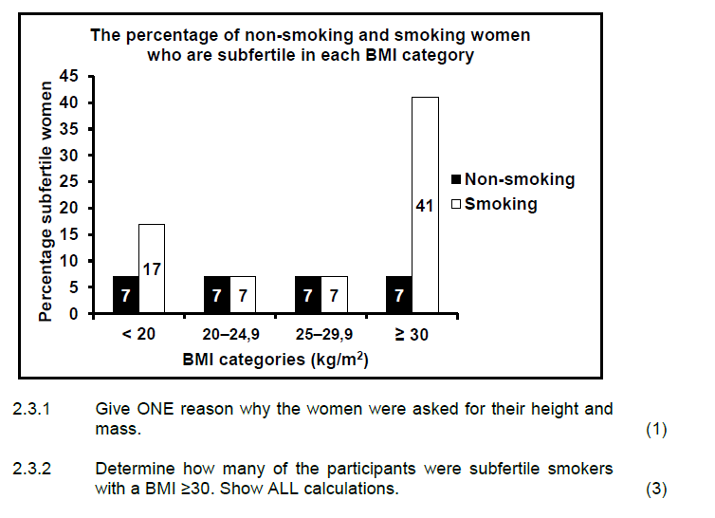

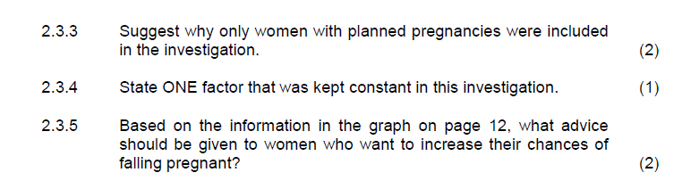

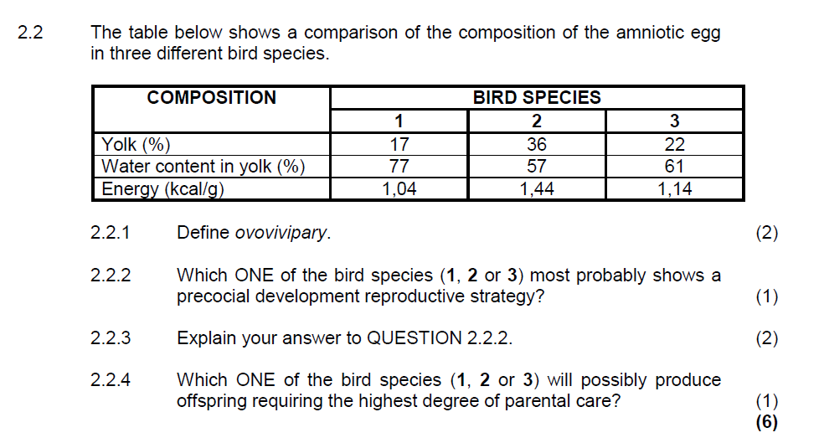

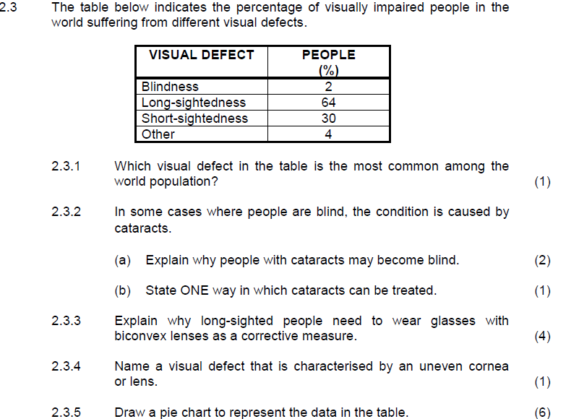

DRAW GRAPHS

* PIE CHART
* LINE GRAPH
* HISTOGRAM
* BAR GRAPHS

**NOVEMBER 2016 (P2)**

