**PHYSICAL SCIENCES – GRADE 12**

**VERTICAL PROJECTILE MOTION IN 1D**

|  |  |  |
| --- | --- | --- |
| **Lesson** | **Date** | **Topic** |
| 2 | 10 February 2024 | Vertical projectile motion: Part 1 |
| 3 | 17 February 2024 | Vertical projectile motion: Part 2 |

**Definitions (as per DBE examination guidelines 2021)**

|  |  |
| --- | --- |
| **Term/ Concept** | **Definition/ Description** |
| **Projectile** | An object which has been given an initial velocity and then it moves under the influence of gravitational force only. |
| **Free fall** | Motion during which the only force acting on an object is the gravitational force. |

**Question 1**

John throws a ball vertically upwards. The ball leaves John’s hand at a velocity of

20 m.s-1.

1.1 Define the term vertical projectile in words.

1.2 Calculate the maximum hight that the ball reaches.

1.3 Calculate the time it will take for the ball to return to the same hight from which it was thrown.

1.4 Draw a position-time graph for the motion from the moment the ball leaves John’s hand, until it is caught at the same position it was thrown from.

1.5 Draw a velocity-time graph for the motion from the moment the ball leaves John’s hand, until it is caught at the same position it was thrown from.

1.6 Draw an acceleration-time graph for the motion from the moment the ball leaves John’s hand, until it is caught at the same position it was thrown from.

**Question 2**

A ball, A, is thrown vertically upward from a height, h, with a speed of 15 m.s-1. AT THE SAME INSTANT, a second identical ball, **B**, is dropped from the same height as ball **A** as shown in the diagram below. Both balls undergo free fall and eventually hit the ground.

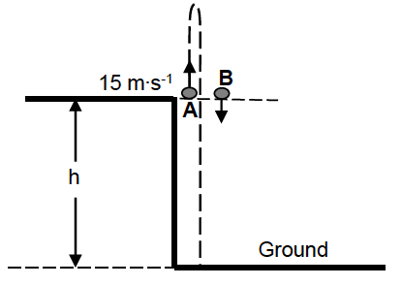

2.1 Explain the term *free fall*.

2.2 Calculate the time it takes for ball **A** to return to its starting point.

2.3 Calculate the distance between ball **A** and ball **B** when ball **A** is at its maximum height.

2.4 Sketch a velocity-time graph for the motion of ball **A** from the time it is projected until it hits the ground. Clearly indicate the following on your graph:

* The initial velocity
* The time it takes to reach its maximum height
* The time it takes to return to its staring point

**Question 3**

A ball is dropped from the top of a building 20 m high. Ignore the effects of air resistance.

3.1 Calculate the speed at which the ball hits the ground.

3.2 Calculate the time it takes the ball to reach the ground.

3.3 Sketch a velocity-time graph for the motion of the ball.

**Question 4**

A ball is thrown **vertically downwards** from the top of a building and bounces a few times as it hits the ground. The velocity-time graph below describes the motion of the ball from the time it is thrown, up to a certain time **T**. Take downwards as the positive direction and the ground as zero reference. The graph is NOT drawn to scale. The effects of air friction are ignored.

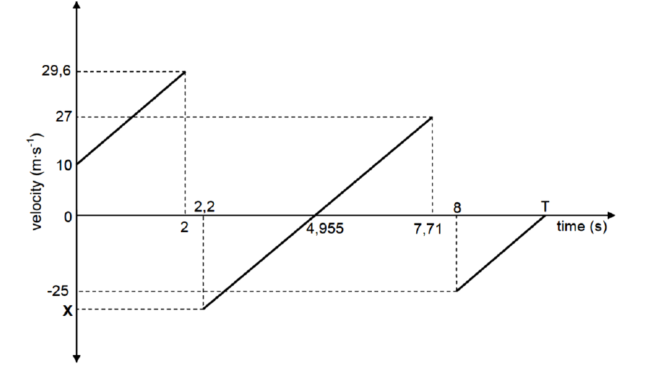

4.1 Write down the speed with which the ball is thrown downwards.

4.2 ALL parts of the graph have the same gradient. Give a reason for this.

4.3 Calculate the height from which the ball is thrown.

4.4 Calculate the time (**T**) shown on the graph.

4.5 Write down the:

4.5.1 time that the ball is in contact with the ground at the first bounce.

4.5.2 time at which the ball reaches its maximum height after the first bounce.

4.5.3 value of **X**.

4.6 Is the collision of the ball with the ground elastic or inelastic? Give a reason for your answer using information in the graph.

**Question 5**

A hot-air balloon moves vertically downwards at a constant velocity of 1,2 m.s-1. When it reaches a hight om 22 m from the ground, a ball is dropped from the balloon.

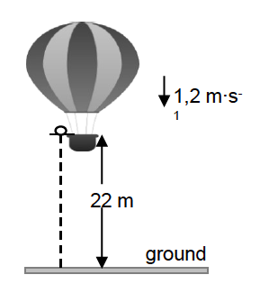

1,2 m.s-1

Assume that the dropping of the ball has no effect on the speed of the hot-air balloon. Ignore air friction for the motion of the ball.

5.1 Is the hot-air balloon in free fall? Give a reason for your answer.

5.2 Calculate the time it takes for the ball to hit the ground after it is dropped.

When the ball lands on the ground, it is in contact with the ground for 0,3 s and then it bounces vertically upwards with a speed of 15 m.s-1.

5.3 Calculate how high the balloon is from the ground when the ball reaches its maximum height after the first bounce.

