**PHYSICAL SCIENCES – GRADE 12**

**VERTICAL PROJECTILE MOTION IN 1D**

|  |  |  |
| --- | --- | --- |
| **Lesson** | **Date** | **Topic** |
| 2 | 10 February 2024 | Vertical projectile motion: Part 1 |
| 3 | 17 February 2024 | Vertical projectile motion: Part 2 |

**Definitions (as per DBE examination guidelines 2021)**

|  |  |
| --- | --- |
| **Term/ Concept** | **Definition/ Description** |
| **Projectile** | An object which has been given an initial velocity and then it moves under the influence of gravitational force only. |
| **Free fall** | Motion during which the only force acting on an object is the gravitational force. |

**Question 4**

A ball is thrown **vertically downwards** from the top of a building and bounces a few times as it hits the ground. The velocity-time graph below describes the motion of the ball from the time it is thrown, up to a certain time **T**. Take downwards as the positive direction and the ground as zero reference. The graph is NOT drawn to scale. The effects of air friction are ignored.

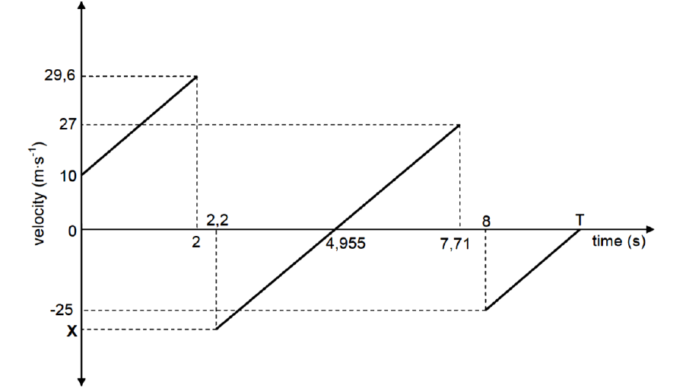

4.1 Write down the speed with which the ball is thrown downwards.

4.2 ALL parts of the graph have the same gradient. Give a reason for this.

4.3 Calculate the height from which the ball is thrown.

4.4 Calculate the time (**T**) shown on the graph.

4.5 Write down the:

4.5.1 time that the ball is in contact with the ground at the first bounce.

4.5.2 time at which the ball reaches its maximum height after the first bounce.

4.5.3 value of **X**.

4.6 Is the collision of the ball with the ground elastic or inelastic? Give a reason for your answer using information in the graph.

**Question 5**

A hot-air balloon moves vertically downwards at a constant velocity of 1,2 m.s-1. When it reaches a hight om 22 m from the ground, a ball is dropped from the balloon.

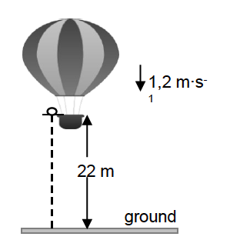

1,2 m.s-1

Assume that the dropping of the ball has no effect on the speed of the hot-air balloon. Ignore air friction for the motion of the ball.

5.1 Is the hot-air balloon in free fall? Give a reason for your answer.

5.2 Calculate the time it takes for the ball to hit the ground after it is dropped.

When the ball lands on the ground, it is in contact with the ground for 0,3 s and then it bounces vertically upwards with a speed of 15 m.s-1.

5.3 Calculate how high the balloon is from the ground when the ball reaches its maximum height after the first bounce.

**DBE MAY/ JUNE 2021**

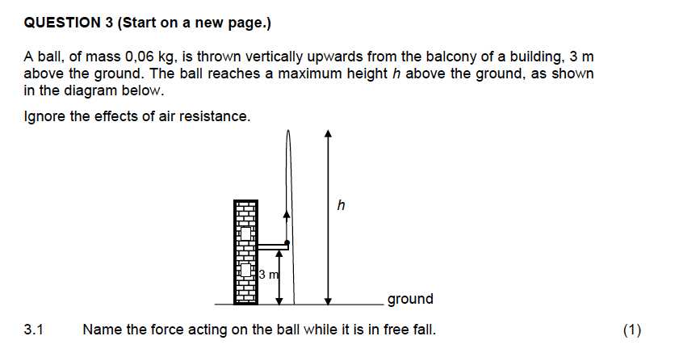

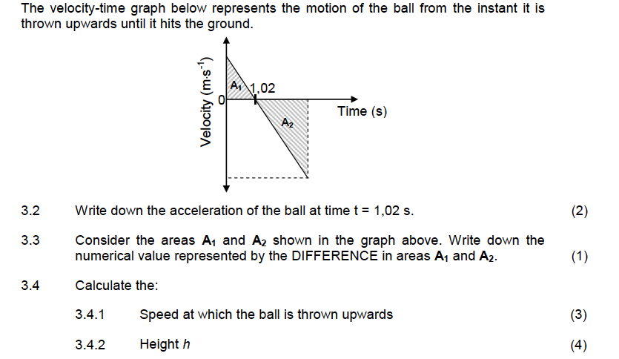

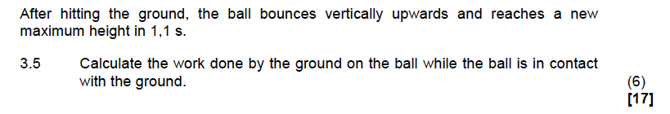

**DBE MAY/ JUNE 2022**

