**SCIENTIFIC INVESTIGATION SKILLS**

THE SKILLS REQUIRED IN LIFE SCIENCES FOR THE NSC EXAMS ARE INDICATED **IN BOLD.**

**INTERPRETING GRAPHS AND DATA**

**NOVEMBER 2016**

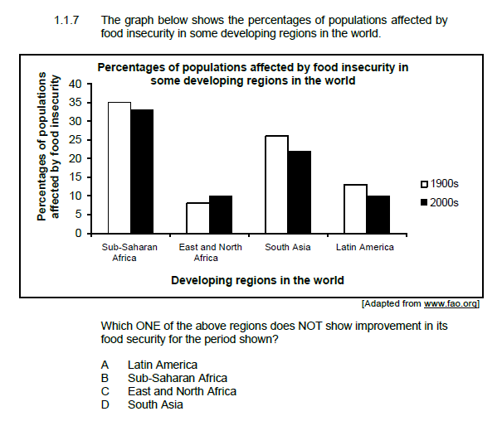

**IDENTIFY VARIABLES**

* INDEPENDENT VARIABLE
* DEPENDENT VARIABLE
* CONTROLLED VARIABLES

Example, an investigation was conducted to determine the effect of brightness of light on the diameter of the pupil of the eye.

**BE ABLE TO WRITE…**

* **HYPOTHESIS**
* **INVESTIGATIVE QUESTION**
* **CONCLUSION**
* **PLANNING**
* **PRECAUTIONS**

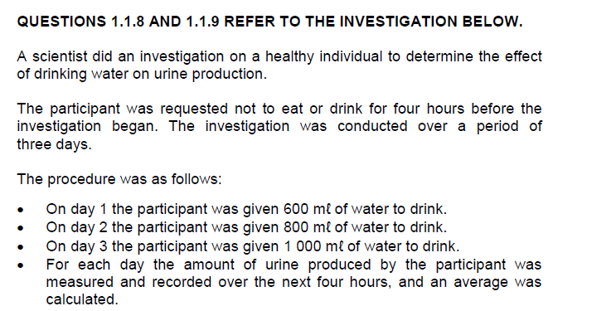

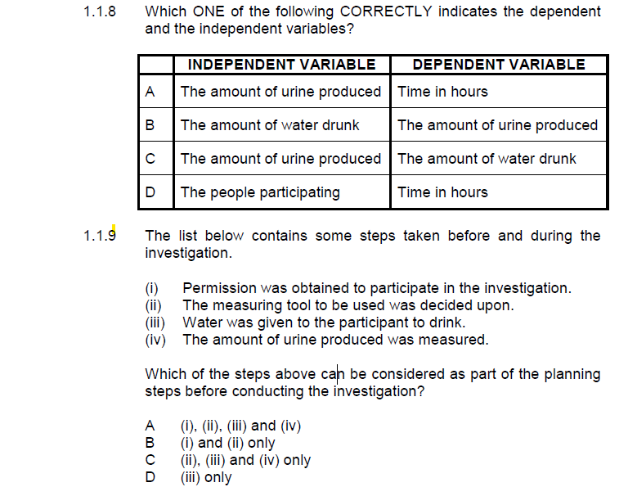

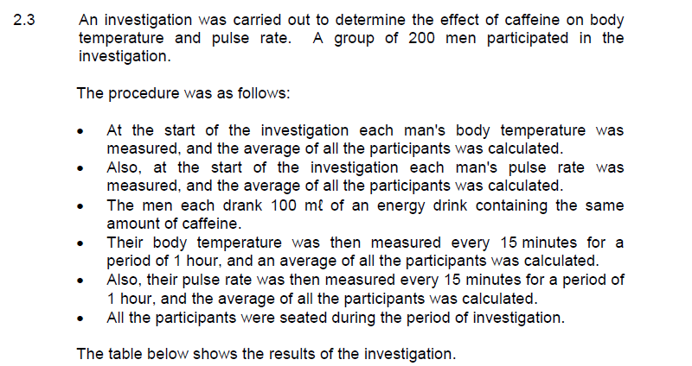

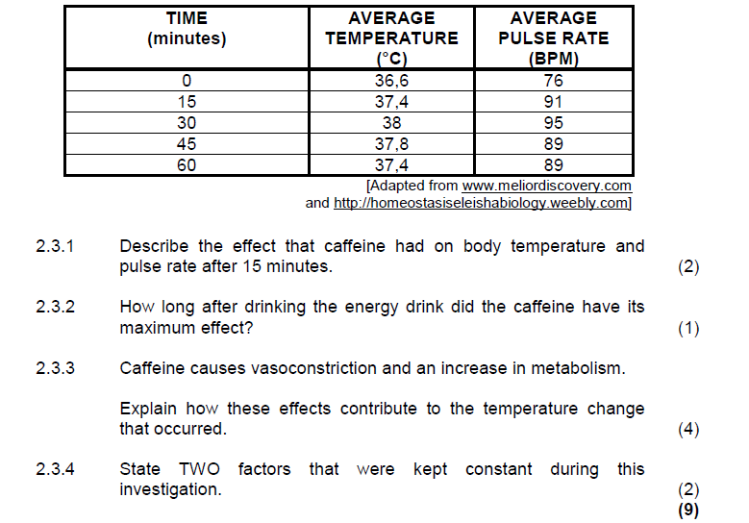

**SIMPLE CALCULATIONS**

* **AVERAGE**
* **DIFFERENCE**
* **%**
* **% INCREASE**
* **HOW MANY TIMES BIGGER**

**Example, the growth rate of a certain plant per day.**

|  |  |  |  |  |  |
| --- | --- | --- | --- | --- | --- |
| **Day** | 1 | 2 | 3 | 4 | 5 |
| **Growth in cm/day** | 0,5 | 1,2 | 2,5 | 0,75 | 0,75 |

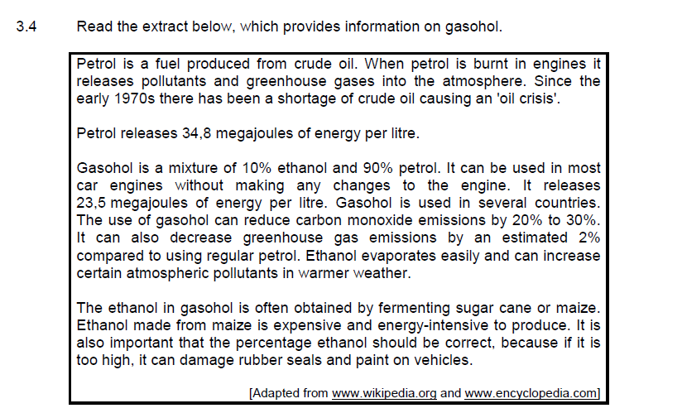

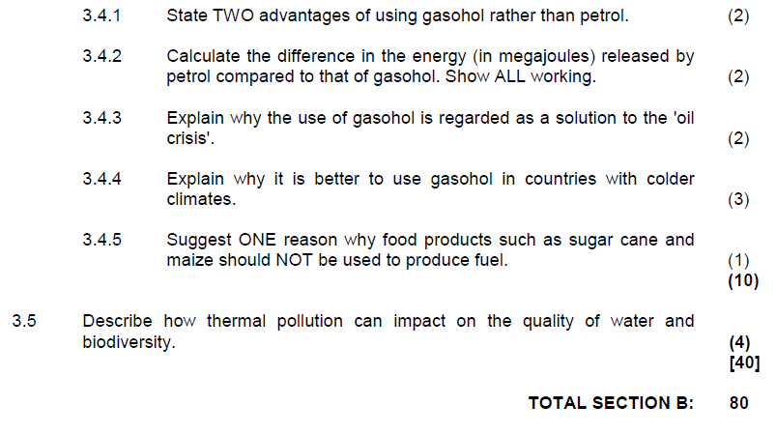

NOVEMBER 2017

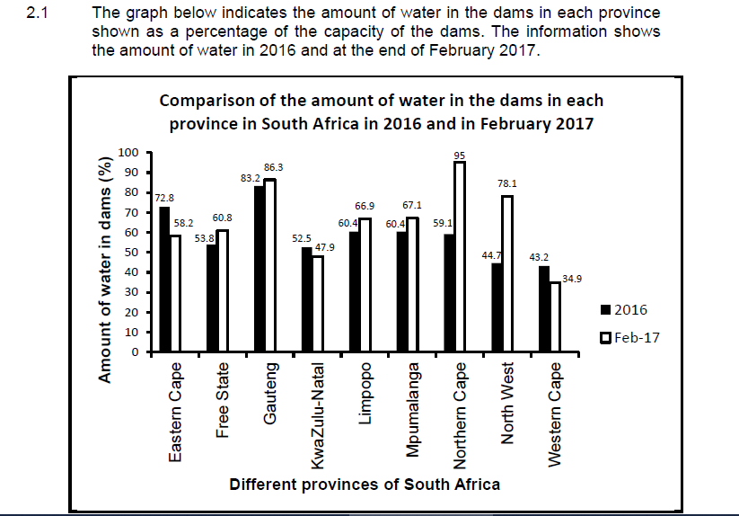

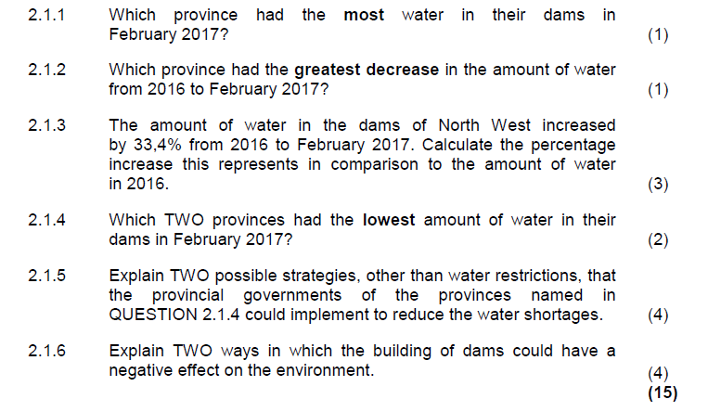

**DRAW DIAGRAMS**

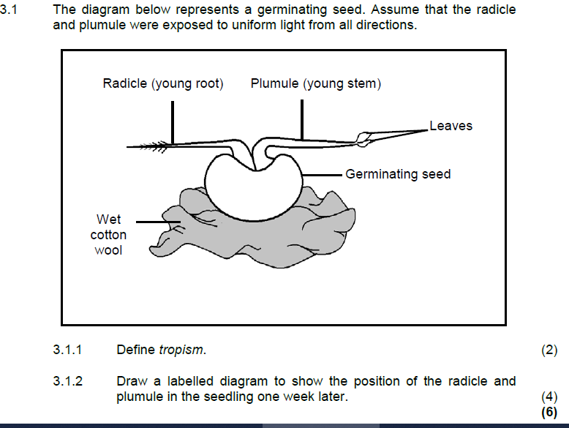

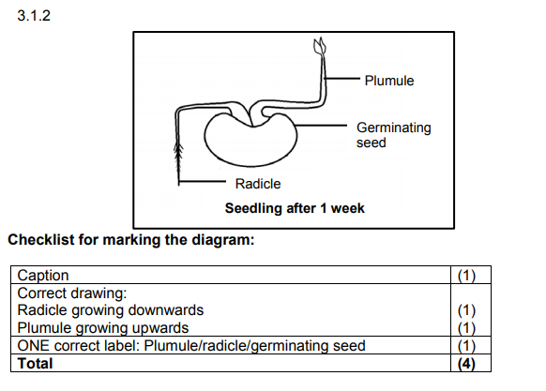

**RELIABILITY AND VALIDITY**

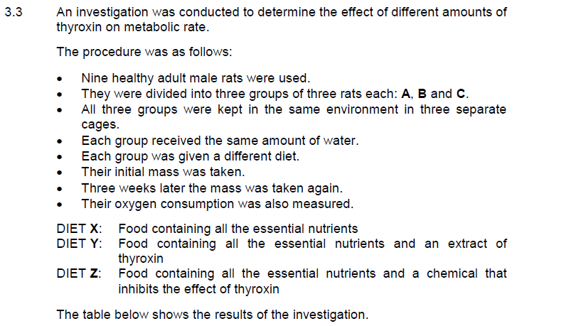

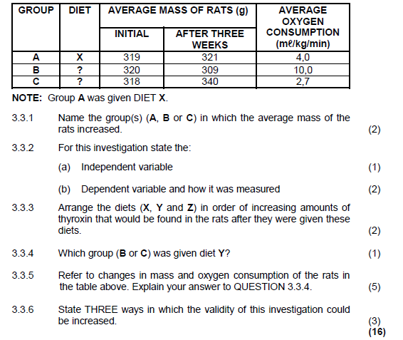

NOVEMBER 2018

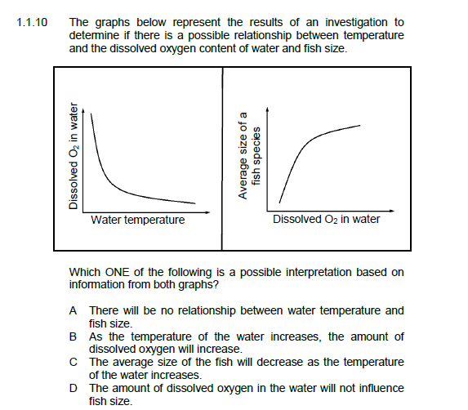

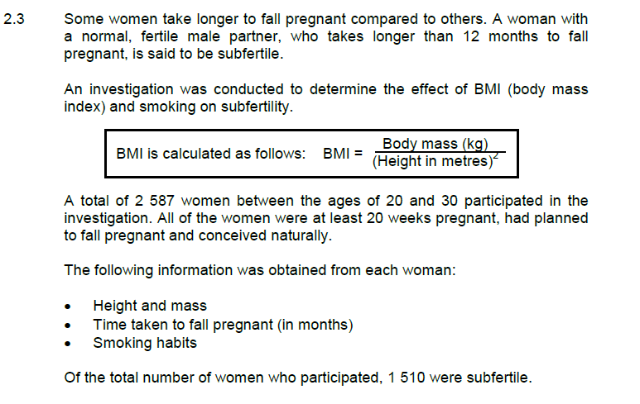

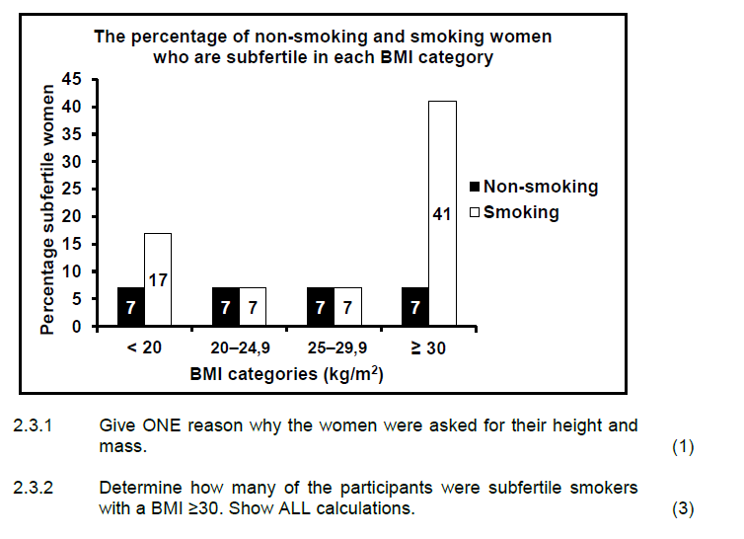

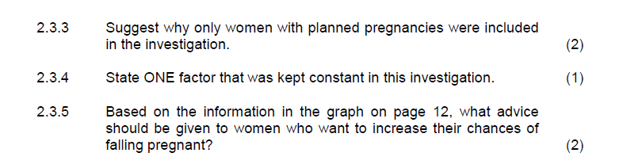

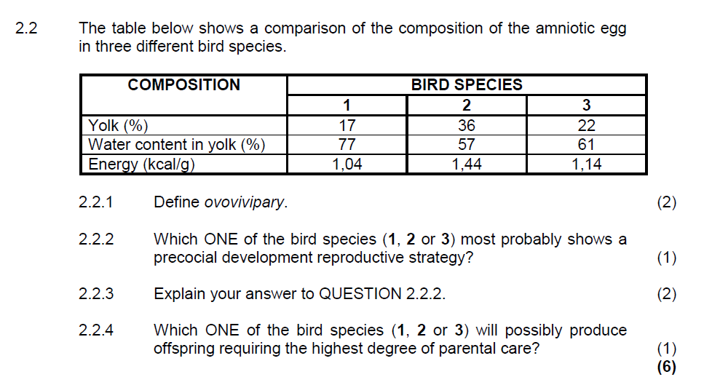

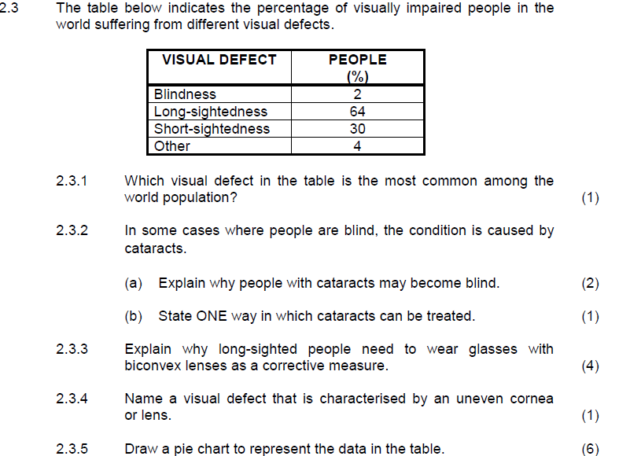

**DRAW GRAPHS**

* **PIE CHART**
* **LINE GRAPH**
* **HISTOGRAM**
* **BAR GRAPHS**

**NOVEMBER 2016 (P2)**

